

**Carrier Trading Center**

Report #3 – Software Requirements Specifications

|  |  |  |
| --- | --- | --- |
| **Carrier Trading Center** | | |
| **Group Members** | Lê Văn Dương | SE03290 |
| Vũ Văn Quyết | SE03344 |
| Đặng Lê Tuấn | SE03807 |
| Trịnh Đình Quyết | SE03159 |
| Lê Gia Hoàng | SE03200 |
| **Supervisor** | Mr. Nguyễn Văn Sang | |
| **Project code** | CTC | |

**- Hanoi, 02/2017-**

# SIGNATURE PAGE

AUTHOR: Trịnh Đình Quyết 15/02/2017

Team member

REVIEWERS: Lê Văn Dương 20/02/2017

Project manager

APPROVAL: Nguyễn Văn Sang --/--/2017

Supervisor

Record of change

*A - Added M - Modified D – Deleted

|  |  |  |  |  |  |
| --- | --- | --- | --- | --- | --- |
| Effective Date | Changed Item | A,M,D | Change Description | Reason for Change | Rev. Number |
| 15/02/2017 | Create Software Requirements Specifications | A | Create Software Requirements Specifications | First version | 1.0 |
|  |  |  |  |  |  |
|  |  |  |  |  |  |
|  |  |  |  |  |  |
|  |  |  |  |  |  |
|  |  |  |  |  |  |
|  |  |  |  |  |  |
|  |  |  |  |  |  |
|  |  |  |  |  |  |
|  |  |  |  |  |  |
|  |  |  |  |  |  |
|  |  |  |  |  |  |
|  |  |  |  |  |  |
|  |  |  |  |  |  |
|  |  |  |  |  |  |
|  |  |  |  |  |  |
|  |  |  |  |  |  |
|  |  |  |  |  |  |
|  |  |  |  |  |  |

Table Contents

SIGNATURE PAGE 2

1. INTRODUCTION 4

1.1. Purpose 4

1.2. Definitions and Acronyms 4

1.3. System Purpose 4

2. OVERALL DESCRIPTION 5

2.1. System overview 5

2.2. Product Features 5

2.2.1. User Characteristics 7

2.2.2. User Documentation 7

2.2.3. Assumption 8

2.3. Entity Relation Model 8

2.3.1. Entity-Relationship Diagram 8

2.3.2. Entity Detail 8

3 FUNCTIONAL SPECIFICATION 13

3.3 Business Rules 13

3.4 Use Cases 14

3.4.2 Guest Group Function 15

3.4.3 Carrier Group Function 22

3.4.4 Goods Owner Group Function 48

3.4.5 Admin Group Function 74

4 NON-FUNCTIONAL SPECIFICATION 108

4.3 Reliability 108

4.4 Performance Requirements 108

4.4.2 Availability 108

4.4.3 Response time 108

4.4.4 Maintainability 108

4.4.5 Usability 108

4.4.6 Security Requirements 109

4.4.7 Hardware/Software Requirements 109

# **INTRODUCTION**

## **Purpose**

This is chapter outlines functional and non-functional requirements of our website. It also provides some format constraints in common requirements and project success criteria. All members will work (design, code, test) based on the information provided in this chapter.

## **Definitions and Acronyms**

|  |  |  |
| --- | --- | --- |
| **Acronym** | **Definition** | **Note** |
| CTC | Carrier trading center |  |
| SRS | Software Requirements Specifications |  |
| Guest | CTC’s user who did not register |  |
| GWN | CTC’s user who registered and they are goods owner |  |
| CRE | CTC’s user who registered and they are carrier |  |
| Admin | Who manage CTC system |  |
| User | Who use CTC system |  |

Table 1.1: Definition and Acronyms

## **System Purpose**

Today we have a lot of ideas to make life better. With the development of information technology, it is easier to implement that idea. The CTC system creates a convenient auction environment where owners and owners can find each other easily and at the most affordable prices. CTC system helps to increase profit for customers and help society develop better. The CTC system is for everyone, everyone can use CTC as a tool as long as they follow our rules.

# **OVERALL DESCRIPTION**

## **System overview**

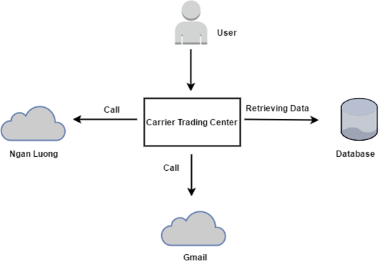

Figure 2-1: System Overview

## **Product Features**

|  |  |  |  |
| --- | --- | --- | --- |
| UC No. | Group Of Functions | Function | Glossary |
| **Guest** | | | |
| UC001 | **Register** | Register a new account |  |
| UC002 | **Bill of lading list** | Search bill of lading |  |
| UC003 | View bill of lading list |  |
| UC004 | **Price list** | View price |  |
| UC005 | Reference price |  |
| **Admin** | | | |
| UC006 | **Bill of lading list** | View bill of lading detail |  |
| UC007 | Search bill of lading |  |
| UC008 | View bill of lading list |  |
| UC009 | View carrier auction success |  |
| UC010 | Summary all bill of lading |  |
| UC011 | View carrier list who are auctioning |  |
| UC012 | **Manage user** | Search user |  |
| UC013 | View user profile |  |
| UC014 | Edit user profile |  |
| UC015 | Add company |  |
| UC016 | Account recharge for user |  |
| UC017 | Active user |  |
| UC018 | Deactivate user |  |
| UC019 | Edit company information |  |
| UC020 | View user list |  |
| UC021 | **Price list** | View price list |  |
| UC022 | Add a new price |  |
| UC023 | View price table history |  |
| UC024 | Edit price list |  |
| UC025 | Reference price |  |
| UC026 | Edit reference price |  |
| UC027 | **Transaction history** | Transaction History |  |
| UC028 | **Login** | Login |  |
| UC029 | **Logout** | Logout |  |
| UC030 | **Manage report** | Search report |  |
| UC031 | Response report |  |
| UC032 | View report list |  |
| UC033 | **Manage profile** | View profile |  |
| UC034 | Edit profile |  |
| UC035 | Forget password |  |
| UC036 | Change password |  |
| **Goods owner** | | | |
| UC037 | **Bill of lading list** | View bill of lading list |  |
| UC038 | View bill of lading detail |  |
| UC039 | Search bill of lading |  |
| UC040 | View carrier auction success |  |
| UC041 | Confirm complete transaction |  |
| UC042 | Post a new bill of lading |  |
| UC043 | Cancel bill of lading |  |
| UC044 | **Manage profile** | Edit profile |  |
| UC045 | View profile |  |
| UC046 | Change password |  |
| UC047 | Forget password |  |
| UC048 | Add company |  |
| UC049 | **Manage report** | Send report |  |
| UC050 | Search report |  |
| UC051 | Cancel report |  |
| UC052 | View report list |  |
| UC053 | **Price list** | Reference price |  |
| UC054 | View price list |  |
| UC055 | **Account recharge** | Account recharge |  |
| UC056 | **Transaction history** | Transaction history |  |
| UC057 | **Login** | Login |  |
| UC058 | **Logout** | Logout |  |
| UC059 | **Connect to carrier** | Connect to carrier |  |
| **Carrier** | | | |
| UC060 | **Bill of lading list** | View bill of lading list |  |
| UC061 | Confirm complete transaction |  |
| UC062 | View bill of lading detail |  |
| UC063 | Auction bill of lading |  |
| UC064 | Search bill of lading |  |
| UC065 | Cancel bill of lading |  |
| UC066 | **Manage profile** | Edit profile |  |
| UC067 | View profile |  |
| UC068 | Change password |  |
| UC069 | Forget password |  |
| UC070 | Add company |  |
| UC071 | **Manage report** | View report list |  |
| UC072 | Search report |  |
| UC073 | Cancel report |  |
| UC074 | Send report |  |
| UC075 | **Price list** | Reference price |  |
| UC076 | View pricing list |  |
| UC077 | **Transaction history** | Transaction history |  |
| UC078 | **Login** | Login |  |
| UC079 | **Logout** | Logout |  |
| UC080 | **Connect to goods owner** | Connect to goods owner |  |
| UC081 | **Account recharge** | Account recharge |  |

Table ‑: List of use case diagram

### **User Characteristics**

The Carrier Trading Center's transport floor is aimed at everyone who wants to use the service. Just follow the rules and steps have been programmed. Those with goods wanting to be transported and those with vehicles wanting to transport goods and improve economic productivity.

Carrier Trading Center has 4 user groups:

* **Guest:** Everyone who does not have account and accessed into the websites.
* **Goods Owner:** Everyone who has account and accessed into Carrier Trading Center Website to register bill of lading.
* **Carrier:** Everyone who has account and accessed into Carrier Trading Center Website to auction bill of lading.
* **Administrator:** A person who has the highest permission level and is responsible for managing the website

### **User Documentation**

|  |  |
| --- | --- |
| Name | Description |
| User Guide | Provide detailed explanation about the system, screens and guide users how to use all features of CTC. |

Table ‑: User Documentation

### **Assumption**

* Receive the guidance and good support of teacher.
* No one of member got sick in the software development process.
* In the development process, no device got fail.
* Every report, task meets the deadline.
* Team member do not conflict in the work process.

## **Entity Relation Model**

### **Entity-Relationship Diagram**

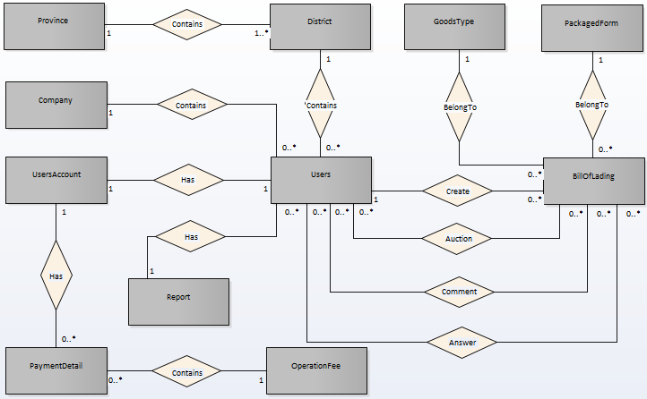

**Figure 2-3:** Entity Relationship Diagram

### **Entity Detail**

#### Table answer comment

|  |  |  |  |  |
| --- | --- | --- | --- | --- |
| NO. | Attribute | Type | Mandatory | Description |
| 1 | Content | Text | Yes | Content of comment |
| 2 | Created User | Text | Yes | Who create comment |
| 3 | Created | Text | NO | Create date |

Table ‑: table answer comment

#### Table bill of lading

|  |  |  |  |  |
| --- | --- | --- | --- | --- |
| NO | Attribute | Type | Mandatory | Description |
| 1 | Goods Image | Text | NO | Image of goods |
| 2 | Weight | Number | YES | Number of goods |
| 3 | Volume | Number | YES | Volume of goods |
| 4 | Quantity | Number | NO | Quality of goods |
| 5 | Length | Number | YES | Length of goods |
| 6 | Width | Number | YES | Width of goods |
| 7 | Height | Number | YES | Height of goods |
| 8 | Description | Text | NO | Goods description |
| 9 | Sender | Text | NO | Name of sender |
| 10 | Sender Phone Number | Text | NO | Phone number of sender |
| 11 | Departure Address | Text | YES | Departure Address |
| 12 | Departure Date | Text | YES | Departure Date |
| 13 | Receiver | Text | NO | Name of receiver |
| 14 | Receiver Phone Number | Text | NO | Phone number of receiver |
| 15 | Arrival Address | Text | NO | Address of arrival |
| 16 | Arrival Date | Text | YES | Date of arrival |
| 17 | Distance | Number | YES | Distance of receiver and sender |
| 18 | Price | Number | Yes | Bid price |
| 19 | Status | Number | Yes | Status of bill of lading |
| 20 | Created User | Text | NO | Name of user create bill of lading |
| 21 | Created | Text | Yes | Create date |
| 22 | Modified | Text | Yes | Date of modified |

Table ‑: Table bill of lading

#### Table carrierauction

|  |  |  |  |  |
| --- | --- | --- | --- | --- |
| NO | Attribute | Type | Mandatory | Description |
| 1 | Carrier | Text | NO | Who have account to carry goods |
| 2 | Auction Date | Text | YES | Date of auction |
| 3 | Modified | Text | NO | Date of modified |
| 4 | Auction Price | Number | YES | Price of auction carrier want to get |
| 5 | Status | Text | YES | Status of bill of lading |

Table ‑: Table carrier auction

#### Table comment

|  |  |  |  |  |
| --- | --- | --- | --- | --- |
| NO | Attribute | Type | Mandatory | Description |
| 1 | Content | Text | YES | Content of comment |
| 2 | Created User | Text | YES | Who create comment |
| 3 | Created | Text | YES | Create date |

Table ‑: Table comment

#### Table company

|  |  |  |  |  |
| --- | --- | --- | --- | --- |
| NO | Attribute | Type | Mandatory | Description |
| 1 | Name | Text | YES | Name of company |
| 2 | Tax Code | Text | YES | Tax code of company |
| 3 | Email | Text | YES | Email of company |
| 4 | Phone Number | Number | YES | Phone number of company |
| 5 | Fax | Text | NO | Fax of company |
| 6 | address | Text | YES | Address of company |

Table ‑: Table company

#### Table district

|  |  |  |  |  |
| --- | --- | --- | --- | --- |
| NO | Attribute | Type | Mandatory | Description |
| 1 | Name | Text | YES | Name of district |

Table ‑: Table district

#### Table goods type

|  |  |  |  |  |
| --- | --- | --- | --- | --- |
| NO | Attribute | Type | Mandatory | Description |
| 1 | Name | Text | YES | Name type of goods |
| 2 | Description | Text | NO | Description of goods type |
| 3 | Reference Price | Number | NO | Reference price of goods type |

Table ‑: Table goods type

#### Table operation fee

|  |  |  |  |  |
| --- | --- | --- | --- | --- |
| NO | Attribute | Type | Mandatory | Description |
| 1 | Fee Name | Text | YES | Name of fee |
| 2 | Fee | Number | NO | How much of fee |
| 3 | Description | Text | NO | Description of fee |

Table ‑: Table operation fee

#### Table packagedform

|  |  |  |  |  |
| --- | --- | --- | --- | --- |
| NO | Attribute | Type | Mandatory | Description |
| 1 | Name | Text | YES | Name of package form |
| 2 | Description | Text | NO | Description of package form |

#### Payment detail

|  |  |  |  |  |
| --- | --- | --- | --- | --- |
| NO | Attribute | Type | Mandatory | Description |
| 1 | Amounts | Text | YES | Amounts of payment |
| 2 | Payment Date | Text | NO | Date of payment |
| 3 | Description | Text | NO | Description of payment |
| 4 | Balance | float | NO | Account balance |

Table ‑: Table payment detail

#### Table province

|  |  |  |  |  |
| --- | --- | --- | --- | --- |
| NO | Attribute | Type | Mandatory | Description |
| 1 | Name | Text | YES | Name of province |

Table ‑: Table payment province

#### Table rport

|  |  |  |  |  |
| --- | --- | --- | --- | --- |
| NO | Attribute | Type | Mandatory | Description |
| 1 | Created User | Text | YES | Who create report |
| 2 | Report Date | Text | YES | Date of create report |
| 3 | Report Title | Text | YES | Title of report |
| 4 | Report Question | Text | NO | Question of report |
| 5 | Report Solution | Text | NO | Solution of report |
| 6 | Report Content | Text | NO | Content of report |
| 7 | Report Reply | Text | NO | Reply content of report |
| 8 | Status | boolean | NO | Status of report |

Table ‑: Table payment report

#### Table users

|  |  |  |  |  |
| --- | --- | --- | --- | --- |
| NO | Attribute | Type | Mandatory | Description |
| 1 | Full Name | Text | YES | Name of user |
| 2 | Email | Text | YES | Email of user |
| 3 | Phone Number | Text | YES | Phone number of user |
| 4 | Address | Text | YES | Address of user |
| 5 | Identity Card Information | Text | YES | Identity card information of user |
| 6 | Role | Text | YES | Kind of user |
| 7 | Created | Text | YES | Date of create user |
| 8 | Company Information | Text | NO | Company information of user |

Table ‑: Table users

#### Table users account

|  |  |  |  |  |
| --- | --- | --- | --- | --- |
| NO | Attribute | Type | Mandatory | Description |
| 1 | Balance | Number | YES | Account balance |
| 2 | Modified | Text | YES | Date of modified |

Table ‑: Table user account

# **FUNCTIONAL SPECIFICATION**

## **Business Rules**

|  |  |
| --- | --- |
| **No** | **Description** |
| **B1** | The full name must be not empty |
| **B2** | The email address must not be empty |
| **B3** | The email must be valid. |
| **B4** | The phone number must be not empty |
| **B5** | The address must be not empty |
| **B6** | The province must be not empty |
| **B7** | The district must be not empty |
| **B8** | The identity card must be not empty |
| **B9** | The identity card place must be not empty |
| **B10** | The identity card date must be not empty |
| **B11** | The password must not be empty |
| **B12** | The password length must be in the range at least 8 character |
| **B13** | Check box kind of user (goods owner or carrier) must be not empty |
| **B14** | The auction is successfully |
| **B15** | The confirm password must be matched with the new password |
| **B16** | Receiver and sender must be not empty |
| **B17** | Received date must be not empty |
| **B18** | Send date must be not empty |
| **B19** | Receiver address and sender address must be not empty |
| **B20** | Auction end date must be not empty |
| **B21** | Proposed price must be not empty |
| **B22** | The email when reset password must be registered before |
| **B23** | One phone number must use for only one account |
| **B24** | One identity card must use for only one account |
| **B25** | One email address must use for only one account |
| **B25** | There are only one kind of goods in a bill of lading |
| **B26** | Account balance more than 0 |
| **B27** | There is at least one user use CTC |
| **B28** | Name of cost must be not empty |
| **B29** | Code of cost must be not empty |
| **B30** | Kind of goods must be not empty |
| **B31** | Cost must be not empty |
| **B32** | Description must be not empty |
| **B33** | There is at least one bill of lading on CTC |
| **B34** | Bill of lading code must be not empty |
| **B35** | Kind of goods must be not empty |
| **B36** | Name of sender must be not empty |
| **B37** | Phone number must be not empty |
| **B38** | Receiver name must be not empty |
| **B39** | Receiver place must be not empty |
| **B40** | All district must be not empty |
| **B41** | All province must be not empty |
| **B42** | Destination must be not empty |
| **B43** | The place to go must be not empty |
| **B44** | Date sent must be not empty |
| **B45** | Date receive must be not empty |
| **B46** | Distance must be not empty |
| **B47** | weigh must be not empty |
| **B48** | number must be not empty |
| **B49** | size must be not empty |
| **B50** | End of auction date must be not empty |

Table ‑: Business rules

## **Use Cases**

|  |  |
| --- | --- |
| **Actor** | **Description** |
| Guest | Everyone who does not have account and accesses into the websites. |
| Carrier | Everyone who has account and accesses into Carrier Trading Center Website to auction bill of lading. |
| Goods Owner | Everyone who has account and accesses into Carrier Trading Center Website to register bill of lading. |
| Administrator | A person who has the highest permission level and is responsible for managing the website. |

Table ‑: Actor description

### **Guest Group Function**

#### Register group function

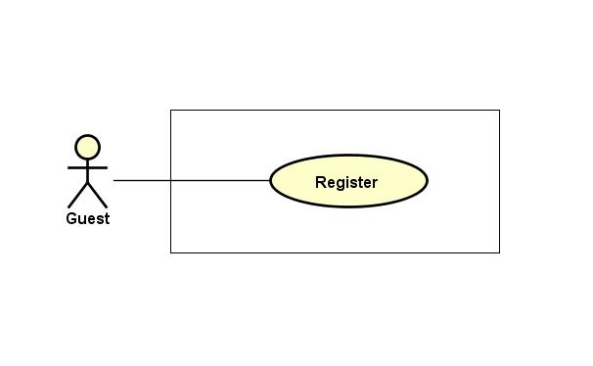

Figure ‑: Register

##### Register

|  |  |  |  |  |  |
| --- | --- | --- | --- | --- | --- |
| **Created by:** | | QuyetTD | | **Date Created:** | 08/03/2017 |
| **Primary Actor** | | Guest | | **Secondary Actor** |  |
| **Description:** | | Guest can create new account to use more function as an unregistered user | | | |
| **Preconditions:** | | The registration button appears on the home screen | | | |
| **Trigger:** | | “Đăng ký” button on the website is clicked | | | |
| **Post conditions:** | | 1. Add exactly account information to database 2. Logs user into system 3. Redirect user to Homepage and display as Member | | | |
| **Normal Flow** | | | | | |
| **Step** | **Actor** | | **Action** | | |
| 1 | Guest | | Click “Đăng ký” in header | | |
| 2 | CTC | | Display Register page includes:   * “Tên đầy đủ” input text * “Email” input text * “Số điện thoại” input text * “Địa chỉ” input text * “Tỉnh/Thành phố” input text * “Quận/Huyện” input text * “Chứng minh thư” input text * “Nơi cấp” input text * “Ngày cấp” date picker * “Chọn ảnh” file chooser * “Mật khẩu” input text * “Xác nhận mật khẩu” input text * “Loại ngườiduùng” check box * “Đăng ký” button | | |
| 3 | Guest | | Enters data in fields | | |
| 4 | Guest | | Click “Đăng ký” button | | |
| 5 | CTC | | Send confirm email, display message “Đăng ký thành công” on register page | | |
| 6 | Guest | | Confirm email | | |
| 7 | CTC | | Activate user account to system | | |
| **Alternative Flows:** | | | | | |
| **AT1** | At step 4 in the main flows, if guest click other hyperlinks or buttons | | | | |
| **Step** | **Actor** | | **Action** | | |
| 4.1 | CTC | | Redirects user to chosen hyperlink or button | | |
| **Exceptions:** | | | | | |
| **EC1** | At step 4, required fields are not entered | | | | |
| **Step** | **Actor** | **Action** | | | |
| 4.1 | CTC | Display Register page with message error | | | |
| 4.2 | CTC | Mark error fields | | | |
| **EC2** | At step 4, fields are entered with wrong type of data | | | | |
| **Step** | **Actor** | **Action** | | | |
| 4.1 | CTC | Display Register page with message error | | | |
| 4.2 | CTC | Mark error fields | | | |
|  | | | | | |
| **Priority** | | High | | | |
| **Frequency of Use:** | | High | | | |
| **Business Rules:** | | B1, B2, B3, B4, B5, B6, B7, B8, B9, B10, B11, B12, B13, 23, 24, 25 | | | |
| **Other Information:** | | N/A | | | |

Table ‑: Register

#### Price list group function

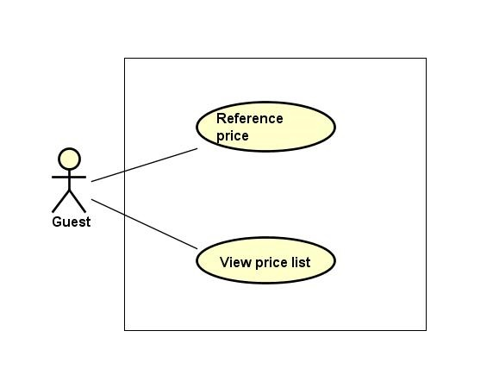

Figure ‑: Price list group function

##### Reference price list

|  |  |  |  |  |
| --- | --- | --- | --- | --- |
| **Created by:** | | QuyetTD | **Date Created:** | 08/03/2017 |
| **Primary Actor** | | Guest | **Secondary Actor** |  |
| **Description:** | | Guest want to reference actual price system updated | | |
| **Preconditions:** | | 1. “Tham Chiếu” item appear on header of website 2. “BÁO GIÁ” navigator appear on header of website | | |
| **Trigger:** | | “Tham Chiếu” item is clicked | | |
| **Post conditions:** | | Display reference price list | | |
| **Normal Flow** | | | | |
| **Step** | **Actor** | **Action** | | |
| 1 | Guest | Hover mouse to “Báo giá” navigator and Click “Tham chiếu” button | | |
| 2 | CTC | Display reference price list | | |
| **Alternative Flows: N/A** | | | | |
| **Exceptions: N/A** | | | | |
| **Priority** | | Medium | | |
| **Frequency of Use:** | | Medium | | |
| **Business Rules:** | | N/A | | |
| **Other Information:** | | N/A | | |

Table ‑: Reference price list

##### View price list

|  |  |  |  |  |
| --- | --- | --- | --- | --- |
| **Created by:** | | QuyetTD | **Date Created:** | 08/03/2017 |
| **Primary Actor** | | Guest | **Secondary Actor** |  |
| **Description:** | | Guest want to view price list | | |
| **Preconditions:** | | 1. “Hệ Thống” item appear on header of website 2. “BÁO GIÁ” navigator appear on header of website | | |
| **Trigger:** | | “Hệ Thống” item is clicked | | |
| **Post conditions:** | | Display price list on this page | | |
| **Normal Flow** | | | | |
| **Step** | **Actor** | **Action** | | |
| 1 | User | Hover mouse to “Tham chiếu” navigator and click “Hệ Thống” on homepage | | |
| 2 | CTC | Display price list | | |
| **Alternative Flows: N/A** | | | | |
| **Exceptions: N/A** | | | | |
| **Priority** | | High | | |
| **Frequency of Use:** | | High | | |
| **Business Rules:** | | N/A | | |
| **Other Information:** | | N/A | | |

Table ‑: View price list

#### Bill of lading list group function

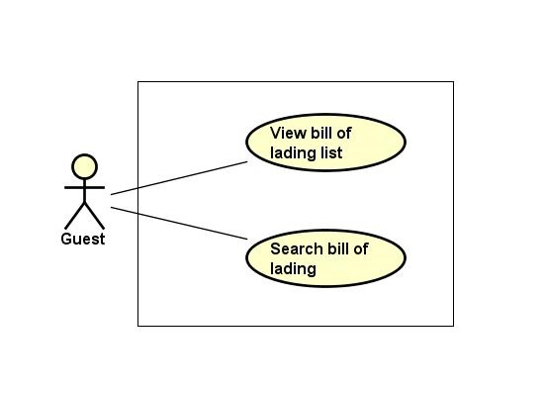

Figure ‑: Bill of lading list group function

##### View bill of lading list

|  |  |  |  |  |
| --- | --- | --- | --- | --- |
| **Created by:** | | QuyetTD | **Date Created:** | 08/03/2017 |
| **Primary Actor** | | Guest | **Secondary Actor** |  |
| **Description:** | | Guest want to view bill of lading list | | |
| **Preconditions:** | | “Tìm Hàng Chuyển” navigator appear header of website | | |
| **Trigger:** | | “Tìm Hàng Chuyển” navigator is cllicked | | |
| **Post conditions:** | | Display bill of lading list on common page | | |
| **Normal Flow** | | | | |
| **Step** | **Actor** | **Action** | | |
| 1 | Guest | Click on “Tìm Hàng Chuyển” navigator on the website | | |
| 2 | CTC | Display bill of lading list on common page | | |
| **Alternative Flows: N/A** | | | | |
| **Exceptions: N/A** | | | | |
| **Priority** | | High | | |
| **Frequency of Use:** | | High | | |
| **Business Rules:** | | N/A | | |
| **Other Information:** | | N/A | | |

Table ‑: View bill of lading list

##### Search bill of lading

|  |  |  |  |  |
| --- | --- | --- | --- | --- |
| **Created by:** | | QuyetTD | **Date Created:** | 08/03/2017 |
| **Primary Actor** | | Guest | **Secondary Actor** |  |
| **Description:** | | Guest want to find a bill of lading | | |
| **Preconditions:** | | 1. “Tìm Hàng Chuyển” navigator appear on header of website 2. Search box appear on common page | | |
| **Trigger:** | | “Tìm Hàng Chuyển” navigator is clicked | | |
| **Post conditions:** | | Display bill of lading system found on common page | | |
| **Normal Flow** | | | | |
| **Step** | **Actor** | **Action** | | |
| 1 | Guest | Click “Tìm Hàng Chuyển” navigator | | |
| 2 | CTC | Display search page includes:   * “Loại hàng” select box * “Hình thức đóng gói” select box * “Khối lượng” input text * “Thể tích” input text * “Địa điểm đi” select box * “Địa điểm đến” select box * “Thời gian đi” Date picker * “Thời gian đến” Date picker * “Tìm Kiếm” buttons | | |
| 3 | Guest | Enter data in this fields | | |
| 4 | Guest | Click “Tìm Kiếm” button | | |
| 5 | CTC | Display result bill of lading list system found | | |
| **Alternative Flows:** | | | | |
| **AT1** | At step 4 in the main flows, if guest click other hyperlinks or buttons | | | |
| **Step** | **Actor** | **Action** | | |
| 5.1 | CTC | Redirects user to chosen hyperlink or button | | |
| **Exceptions: N/A** | | | | |
| **Priority** | | Medium | | |
| **Frequency of Use:** | | Medium | | |
| **Business Rules:** | | N/A | | |
| **Other Information:** | | N/A | | |

Table ‑: Search bill of lading

### **Carrier Group Function**

#### Bill of lading list group function

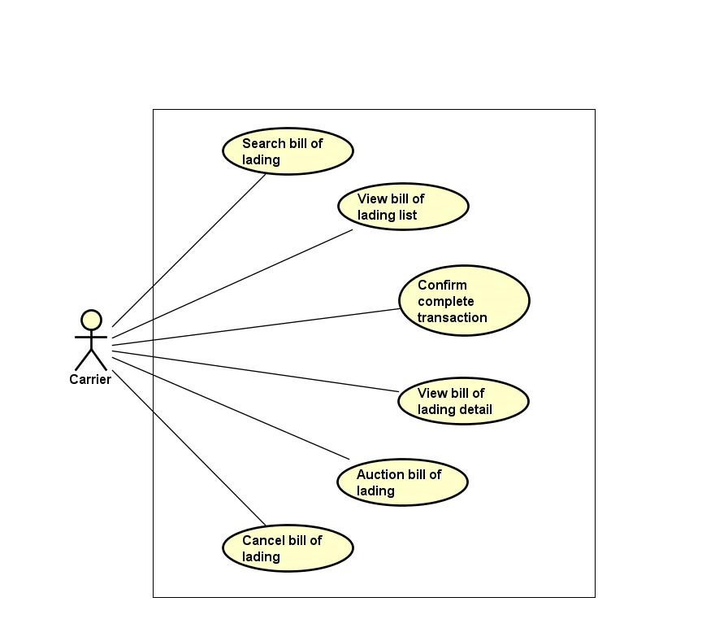

Figure ‑: of lading list group function

##### View bill of lading list

|  |  |  |  |  |
| --- | --- | --- | --- | --- |
| **Created by:** | | QuyetTD | **Date Created:** | 08/03/2017 |
| **Primary Actor** | | Carrier | **Secondary Actor** |  |
| **Description:** | | CRE want to view all bill of lading | | |
| **Preconditions:** | | “Tìm Hàng Chuyển” navigator appear on header of website | | |
| **Trigger:** | | “Tìm Hàng Chuyển” navigator is clicked | | |
| **Post conditions:** | | Display bill of lading list on common page | | |
| **Normal Flow** | | | | |
| **Step** | **Actor** | **Action** | | |
| 1 | CRE | Click “Tìm Hàng Chuyển” navigator | | |
| 2 | CTC | Display bill of lading list on common page | | |
| **Alternative Flows: N/A** | | | | |
| **Exceptions: N/A** | | | | |
| **Priority** | | Medium | | |
| **Frequency of Use:** | | High | | |
| **Business Rules:** | | N/A | | |
| **Other Information:** | | N/A | | |

Table ‑: View bill of lading list

##### View bill of lading detail

|  |  |  |  |  |
| --- | --- | --- | --- | --- |
| **Created by:** | | QuyetTD | **Date Created:** | 08/03/2017 |
| **Primary Actor** | | Carrier | **Secondary Actor** |  |
| **Description:** | | CRE want to view bill of lading detail, they send request to system and then get result | | |
| **Preconditions:** | | 1. “Tìm Hàng Chuyển” navigator appear on homepage 2. Detail icon appear on bill of lading detail page | | |
| **Trigger:** | | Detail icon of bill of lading is clicked | | |
| **Post conditions:** | | Display bill of lading detail on this page | | |
| **Normal Flow** | | | | |
| **Step** | **Actor** | **Action** | | |
| 1 | CRE | Click “Tim Hàng Vận Chuyển” navigator | | |
| 2 | CTC | Display bill of lading list page | | |
| 3 | CRE | Click “Chi Tiết” on bill of lading | | |
| 4 | CTC | Display bill of lading detail on bill of lading detail page | | |
| **Alternative Flows: N/A** | | | | |
| **Exceptions: N/A** | | | | |
| **Priority** | | High | | |
| **Frequency of Use:** | | High | | |
| **Business Rules:** | | B33 | | |
| **Other Information:** | | N/A | | |

Table ‑: View bill of lading detail

##### Confirm complete transaction

|  |  |  |  |  |
| --- | --- | --- | --- | --- |
| **Created by:** | | QuyetTD | **Date Created:** | 08/03/2017 |
| **Primary Actor** | | Carrier | **Secondary Actor** |  |
| **Description:** | | Carrier want to confirm to system that they are complete bill of lading. It’s mean that their customer got goods. They will get down payment back | | |
| **Preconditions:** | | 1. Bill of lading was successful 2. “Đã Giao Hàng” button appear detail bill of lading page | | |
| **Trigger:** | | “Đã Giao Hàng” button in bill of lading detail page is clicked | | |
| **Post conditions:** | | Return down payment of customer to account and update bill of lading detail page | | |
| **Normal Flow** | | | | |
| **Step** | **Actor** | **Action** | | |
| 1 | CRE | Click “Đã Giao Hàng” button | | |
| 2 | CTC | Display bill of lading detail page update | | |
| 3 | CTC | Refund deposit for carrier | | |
| **Alternative Flows: N/A** | | | | |
| **Exceptions: N/A** | | | | |
| **Priority** | | Medium | | |
| **Frequency of Use:** | | Medium | | |
| **Business Rules:** | | B14 | | |
| **Other Information:** | | N/A | | |

Table ‑:Confirm complete transaction

##### Auction bill of lading

|  |  |  |  |  |  |
| --- | --- | --- | --- | --- | --- |
| **Created by:** | | QuyetTD | | **Date Created:** | 08/03/2017 |
| **Primary Actor** | | Carrier | | **Secondary Actor** |  |
| **Description:** | | Carrier want to transport goods and then they auction bill of lading on CTC | | | |
| **Preconditions:** | | 1. There is a bill of lading auctioning | | | |
| **Trigger:** | | “Đấu Thầu” button on bill of lading detail page is clicked | | | |
| **Post conditions:** | | Auction bill of lading on system | | | |
| **Normal Flow** | | | | | |
| **Step** | **Actor** | **Action** | | | |
| 1 | CRE | Click “Đấu Thầu” button on bill of lading detail page | | | |
| 2 | CTC | Display “Đấu Giá” pop-up includes:   * Account balance * Ceiling price * Service charge * “Giá Đấu Thầu” input text * “Xác Nhận” button * “Hủy Bỏ” button | | | |
| 3 | CRE | Enter data in “Giá Đấu Thầu” input text | | | |
| 4 | CRE | Click “Xác Nhận” button | | | |
| 5 | CTC | Save data in database | | | |
| 6 | CTC | Update bill of lading detail page. | | | |
| **Alternative Flows:** | | | | | |
| **AT1** | At step 4, CRE click “Hủy Bỏ” button | | | | |
| **Step** | **Actor** | **Action** | | | |
| 6.1 | CTC | Return bill of lading detail page | | | |
| **AT2** | At step 4 in the main flows, if CRE click other hyperlinks or buttons | | | | |
| **Step** | **Actor** | | **Action** | | |
| 6.1 | CTC | | Redirects user to chosen hyperlink or button | | |
| **Exceptions: N/A** | | | | | |
| **Priority** | | High | | | |
| **Frequency of Use:** | | High | | | |
| **Business Rules:** | | B33 | | | |
| **Other Information:** | | N/A | | | |

Table ‑: Auction bill of lading

##### Search bill of lading

|  |  |  |  |  |
| --- | --- | --- | --- | --- |
| **Created by:** | | QuyetTD | **Date Created:** | 08/03/2017 |
| **Primary Actor** | | Carrier | **Secondary Actor** |  |
| **Description:** | | CRE want to find a bill of lading | | |
| **Preconditions:** | | 1. “Tìm Hàng Chuyển” navigator appear on header of website 2. Search box appear on common page | | |
| **Trigger:** | | “Tìm Hàng Chuyển” navigator is clicked | | |
| **Post conditions:** | | Display bill of lading system found on common page | | |
| **Normal Flow** | | | | |
| **Step** | **Actor** | **Action** | | |
| 1 | CRE | Click “Tìm Hàng Chuyển” navigator one website | | |
| 2 | CTC | Display summary bill of lading page includes:   * “Loại hàng select box * “Hình thức đóng gói” select box * “Khối lượng” input text * “Thể tích” input text * “Địa điểm đi” select box * “Địa điểm đến” select box * “Thời gian đi” Date picker * “Thời gian đến” Date picker * “Tìm Kiếm” buttons | | |
| 1 | CRE | Enter data in this fields | | |
| 2 | CRE | Click “Tìm Kiếm” button search page | | |
| 3 | CTC | Display result on common page | | |
| **Alternative Flows: N/A** | | | | |
| **Exceptions: N/A** | | | | |
| **Priority** | | High | | |
| **Frequency of Use:** | | high | | |
| **Business Rules:** | | N/A | | |
| **Other Information:** | | N/A | | |

Table ‑: Search bill of lading

##### Cancel bill of lading

|  |  |  |  |  |
| --- | --- | --- | --- | --- |
| **Created by:** | | QuyetTD | **Date Created:** | 08/03/2017 |
| **Primary Actor** | | Carrier | **Secondary Actor** |  |
| **Description:** | | CRE do not want to transport their goods. So they cancel bill of lading | | |
| **Preconditions:** | | Cancel button appear on bill of lading detail page | | |
| **Trigger:** | | “Hủy Đấu Giá” button is clicked | | |
| **Post conditions:** | | Bill of lading will be disable | | |
| **Normal Flow** | | | | |
| **Step** | **Actor** | **Action** | | |
| 1 | CRE | Click “Hủy Đấu Giá” button | | |
| 2 | CTC | Cancel bill of lading | | |
| 3 | CTC | Update bill of lading detail page | | |
| **Alternative Flows:** | | | | |
| **Exceptions: N/A** | | | | |
| **Priority** | | High | | |
| **Frequency of Use:** | | High | | |
| **Business Rules:** | | N/A | | |
| **Other Information:** | | N/A | | |

Table ‑: Cancel bill of lading

#### Manage profile group function

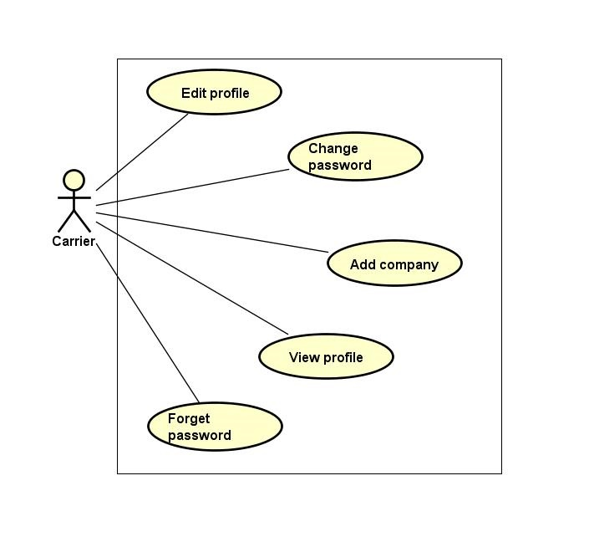

Figure ‑: Manage profile group function

##### Edit profile

|  |  |  |  |  |
| --- | --- | --- | --- | --- |
| **Created by:** | | QuyetTD | **Date Created:** | 08/03/2017 |
| **Primary Actor** | | Carrier | **Secondary Actor** |  |
| **Description:** | | CRE want to edit goods owner profile | | |
| **Preconditions:** | | “Thay Đổi” button appear on detail user view page | | |
| **Trigger:** | | “Thay Đổi” button on detail user view page is clicked | | |
| **Post conditions:** | | Save carrier profile in database and updated detail user view page | | |
| **Normal Flow** | | | | |
| **Step** | **Actor** | **Action** | | |
| 1 | CRE | Carrier click “Thay Đổi” button | | |
| 2 | CTC | Display pop-up includes:   * “Chọn ảnh” file chooser * “Họ tên” input text * “Bạn là” (phân quyền quản trị) check box * “Email” input text * “Địa chỉ” input text * “Chứng minh thư” input text * “Ngày cấp thẻ” date picker * “Ngày tham gia” date picker * “Thay Đổi” button | | |
| 3 | CRE | Change data in this fields | | |
| 4 | CRE | Click “Lưu Thay Đổi” button | | |
| 5 | CTC | Save changed in database | | |
| 6 | CTC | Display changed on user detail page | | |
| **Alternative Flows:** | | | | |
| **AT1** | At step 4, carrier click “x” in pop-up | | | |
| **Step** | **Actor** | **Action** | | |
| 4.1 | CRE | click “x” in pop-up | | |
| 6.1 | CTC | Display user detail page | | |
| **AT2** | At step 4 in the main flows, if CRE click other hyperlinks or buttons | | | |
| **Step** | **Actor** | **Action** | | |
| 6.1 | CTC | Redirects admin to chosen hyperlink or button | | |
| **Exceptions: N/A** | | | | |
| **Priority** | | Medium | | |
| **Frequency of Use:** | | Medium | | |
| **Business Rules:** | | N/A | | |
| **Other Information:** | | N/A | | |

Table ‑: Edit profile

##### View profile

|  |  |  |  |  |
| --- | --- | --- | --- | --- |
| **Created by:** | | QuyetTD | **Date Created:** | 08/03/2017 |
| **Primary Actor** | | Carrier | **Secondary Actor** |  |
| **Description:** | | Carrier want to view their profile | | |
| **Preconditions:** | | “Thông Tin Cá Nhân” item appear on top navigator | | |
| **Trigger:** | | “Thông Tin Cá Nhân” item is clicked | | |
| **Post conditions:** | | Display carrier profile | | |
| **Normal Flow** | | | | |
| **Step** | **Actor** | **Action** | | |
| 1 | CRE | Hover mouse to user name label and click “Thông Tin Cá Nhân” item | | |
| 2 | CTC | Display CRE detail on user detail view page | | |
| **Alternative Flows:** N/A | | | | |
| **Exceptions: N/A** | | | | |
| **Priority** | | Medium | | |
| **Frequency of Use:** | | High | | |
| **Business Rules:** | | N/A | | |
| **Other Information:** | | N/A | | |

Table ‑: View bill of lading

##### Forget password

|  |  |  |  |  |
| --- | --- | --- | --- | --- |
| **Created by:** | | QuyetTD | **Date Created:** | 08/03/2017 |
| **Primary Actor** | | Carrier | **Secondary Actor** |  |
| **Description:** | | CRE forget password. They want to reset password | | |
| **Preconditions:** | | “Quên mật khẩu” label appear on login page | | |
| **Trigger:** | | “Quên mật khẩu” label on login page is clicked | | |
| **Post conditions:** | | System send new password to goods owner’s email | | |
| **Normal Flow** | | | | |
| **Step** | **Actor** | **Action** | | |
| 1 | CRE | CRE click “Quên mật khẩu” on login page | | |
| 2 | CTC | Display forget password page includes:   * “Email đăng ký” input text * “Gửi” button | | |
| 3 | CRE | Enter email address they use for register goods owner account | | |
| 4 | CTC | Send new password to goods owner’s email address | | |
| **Alternative Flows: N/A** | | | | |
| **Exceptions: N/A** | | | | |
| **Priority** | | Medium | | |
| **Frequency of Use:** | | High | | |
| **Business Rules:** | | B22 | | |
| **Other Information:** | | N/A | | |

Table ‑: Forget password

##### Add company

|  |  |  |  |  |  |
| --- | --- | --- | --- | --- | --- |
| **Created by:** | | | QuyetTD | **Date Created:** | 08/03/2017 |
| **Primary Actor** | | | Carrier | **Secondary Actor** |  |
| **Description:** | | | Carrier want to add company information to their profile. | | |
| **Preconditions:** | | | “Thêm mới” button appear below “THÔNG TIN CÔNG TY” label | | |
| **Trigger:** | | | “Thêm mới” button on view user detail page is cliecked | | |
| **Post conditions:** | | | Add company information to user | | |
| **Normal Flow** | | | | | |
| **Step** | **Actor** | | **Action** | | |
| 1 | CRE | | Click “Thêm mới” button on view user detail page | | |
| 2 | CTC | | Display add company information for user pop-up includes:   * “Tên công ty” input text * “Email” input text * “Số điện thoại” input text * “Fax” input text * “Địa chỉ” input text * “Mã số thuế” input text * “Hủy bỏ” button | | |
| 3 | CRE | | * Enter data on fields * Click “Xác nhận” button | | |
| 4 | CTC | | * Add company information for user | | |
| **Alternative Flows: N/A** | | | | | |
| **AT1** | At step 3 in the main flows, CRE click “Hủy bỏ” button | | | | |
| **Step** | **Actor** | | **Action** | | |
| 4.1 | CTC | | Close “Thêm thông tin công ty” pop-up | | |
| **Exceptions: N/A** | | | | | |
| **EC1** | | At step 3, required fields are not entered | | | |
| **Step** | | **Actor** | **Action** | | |
| 6.1 | | CTC | Display Register page with message error | | |
| 6.2 | | CTC | Mark error fields | | |
| **EC2** | | At step 3, fields are entered with wrong type of data | | | |
| **Step** | | **Actor** | **Action** | | |
| 6.1 | | CTC | Display Register page with message error | | |
| 6.2 | | CTC | Mark error fields | | |
| **Priority** | | | Medium | | |
| **Frequency of Use:** | | | Medium | | |
| **Business Rules:** | | | N/A | | |
| **Other Information:** | | | N/A | | |

Table ‑: Add company

##### Change password

|  |  |  |  |  |  |  |
| --- | --- | --- | --- | --- | --- | --- |
| **Created by:** | | | QuyetTD | | **Date Created:** | 08/03/2017 |
| **Primary Actor** | | | Carrier | | **Secondary Actor** |  |
| **Description:** | | | Carrier want to change password for security | | | |
| **Preconditions:** | | | “Thay đổi mật khẩu” item appear on top navigator | | | |
| **Trigger:** | | | “Thay đổi mật khẩu” item is clicked | | | |
| **Post conditions:** | | | Change password of goods owner | | | |
| **Normal Flow** | | | | | | |
| **Step** | **Actor** | | **Action** | | | |
| 1 | CRE | | Click “Thay đổi mật khẩu” label | | | |
| 2 | CTC | | Display change password page includes:   * “Mật khẩu cũ” input text * “Mật khẩu mới” input text * “Xác nhận mật khẩu” input text * “Đổi mật khẩu” button | | | |
| 3 | CRE | | Enter data in this fields | | | |
| 4 | CRE | | Click “Đổi mật khẩu” button | | | |
| 5 | CTC | | Save new password in database | | | |
| 6 | CTC | | Display “Thay đổi thành công” message on pop-up | | | |
| **Alternative Flows:** | | | | | | |
| **AT1** | At step 4 in the main flows, if CRE click other hyperlinks or buttons | | | | | |
| **Step** | **Actor** | | **Action** | | | |
| 6.1 | CTC | | Redirects CRE to chosen hyperlink or button | | | |
| **Exceptions:** | | | | | | |
| **EC1** | | At step 3, required fields are not entered | | | | |
| **Step** | | **Actor** | | **Action** | | |
| 6.1 | | CTC | | Display Register page with message error | | |
| 6.2 | | CTC | | Mark error fields | | |
| **EC2** | | At step 3, fields are entered with wrong type of data | | | | |
| **Step** | | **Actor** | | **Action** | | |
| 6.1 | | CTC | | Display Register page with message error | | |
| 6.2 | | CTC | | Mark error fields | | |
| **EC3** | | At step 3, password is wrong | | | | |
| **Step** | | **Actor** | | **Action** | | |
| 6.1 | | CTC | | Display Register page with message error | | |
| 6.2 | | CTC | | Mark error fields | | |
| **EC4** | | At step 3, new password and confirm password are not match | | | | |
| **Step** | | **Actor** | | **Action** | | |
| 6.1 | | CTC | | Display Register page with message error | | |
| 6.2 | | CTC | | Mark error fields | | |
| **Priority** | | | Medium | | | |
| **Frequency of Use:** | | | Medium | | | |
| **Business Rules:** | | | B12, B15 | | | |
| **Other Information:** | | | N/A | | | |

Table ‑: Change password

#### Account recharge group function

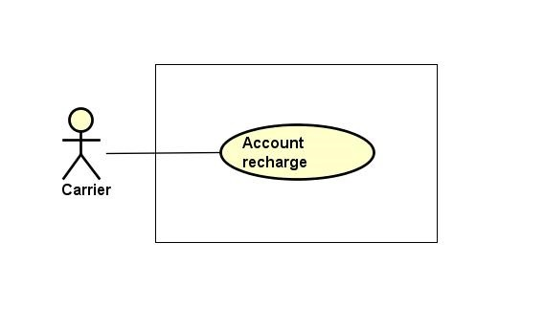

Figure ‑: Account recharge group function

##### Account recharge

|  |  |  |  |  |
| --- | --- | --- | --- | --- |
| **Created by:** | | QuyetTD | **Date Created:** | 08/03/2017 |
| **Primary Actor** | | Carrier | **Secondary Actor** |  |
| **Description:** | | Carrier want to account recharge to account for auction bill of lading | | |
| **Preconditions:** | | “Nạp tiền vào tài khoản” item appear on top navigator | | |
| **Trigger:** | | “Nạp tiền vào tài khoản” item is clicked | | |
| **Post conditions:** | | Recharge the user account | | |
| **Normal Flow** | | | | |
| **Step** | **Actor** | **Action** | | |
| 1 | CRE | Hover mouse to user name and Click “Nạp tiền vào tài khoản” item | | |
| 2 | CTC | Display “nganluong.vn” website includes 3 item for 3 way to recharge to account:   * “Ví điện thứ Ngân Lượng” button * “Thẻ cào điện thoại” button * “Online bằng thẻ ATM\Internet banking” button * “Chuyển khoản ngân hàng” button | | |
| 3 | CRE | Click one of three button for choose how to recharge to account | | |
| 4 | CTC | Display the way user chose to recharge account | | |
| 5 | CRE | GWN do something follow “Ngân Lượng” guide | | |
| 6 | CTC | Add money to user account | | |
| **Alternative Flows:** | | | | |
| **AT1** | At step 4 in the main flows, if CRE click other hyperlinks or buttons | | | |
| **Step** | **Actor** | **Action** | | |
| 5.1 | CTC | Redirects user to chosen hyperlink or button | | |
| **Exceptions: N/A** | | | | |
| **Priority** | | High | | |
| **Frequency of Use:** | | High | | |
| **Business Rules:** | | N/A | | |
| **Other Information:** | | N/A | | |

Table ‑: Account recharge

#### Manage report group function

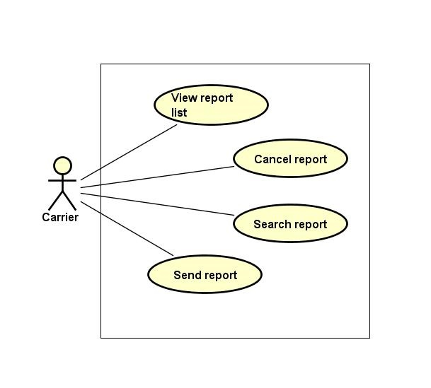

Figure ‑: Manage report group function

##### Send report

|  |  |  |  |  |  |
| --- | --- | --- | --- | --- | --- |
| **Created by:** | | | QuyetTD | **Date Created:** | 08/03/2017 |
| **Primary Actor** | | | Carrier | **Secondary Actor** |  |
| **Description:** | | | Carrier want to send report to admin | | |
| **Preconditions:** | | | 1. “BÁO CÁO CỦA TÔI” navigator appear on header of website 2. “Tạo báo cáo mới” button appear on list report user page | | |
| **Trigger:** | | | “Tạo mới báo cáo” button is clicked | | |
| **Post conditions:** | | | Send report to admin | | |
| **Normal Flow** | | | | | |
| **Step** | **Actor** | | **Action** | | |
| 1 | CRE | | Click “Tạo mới báo cáo” button | | |
| 2 | CTC | | Display add new report page includes:   * “Chủ đề bạn muốn báo cáo là gì” input text * “Câu hỏi của bạn là gì” input text * “Bạn mong muốn xử lý như thế nào” input text * “Nội dung báo cáo của bạn” input text * “Gửi phản hồi” button * “Quay lại” button | | |
| 3 | CRE | | Enter data in fields | | |
| 4 | CRE | | Click “Gửi phản hồi” button | | |
| 5 | CTC | | Send report to admin | | |
| **Alternative Flows:** | | | | | |
| **AT1** | At step 4, CRE click “Quay lại” button | | | | |
| **Step** | **Actor** | | **Action** | | |
| 5.1 | CTC | | Return report list page | | |
| **AT2** | At step 4 in the main flows, if CRE click other hyperlinks or buttons | | | | |
| **Step** | **Actor** | | **Action** | | |
| 5.1 | CTC | | Redirects CRE to chosen hyperlink or button | | |
| **Exceptions:** | | | | | |
| **EC1** | | At step 3, required fields are not entered | | | |
| **Step** | | **Actor** | **Action** | | |
| 5.1 | | CTC | Display Register page with message error | | |
| 5.2 | | CTC | Mark error fields | | |
| **Priority** | | | Medium | | |
| **Frequency of Use:** | | | Medium | | |
| **Business Rules:** | | | N/A | | |
| **Other Information:** | | | N/A | | |

Table ‑: Send report

##### View report list

|  |  |  |  |  |
| --- | --- | --- | --- | --- |
| **Created by:** | | QuyetTD | **Date Created:** | 08/03/2017 |
| **Primary Actor** | | Carrier | **Secondary Actor** |  |
| **Description:** | | CRE want to view report list | | |
| **Preconditions:** | | “BÁO CÁO CỦA TÔI” navigator appear on header of website | | |
| **Trigger:** | | “BÁO CÁO CỦA TÔI” navigator is clicked | | |
| **Post conditions:** | | Display report list on report list page | | |
| **Normal Flow** | | | | |
| **Step** | **Actor** | **Action** | | |
| 1 | CRE | Click “Báo Cáo Của Tôi” navigator | | |
| 2 | CTC | Display report list on report list page | | |
| **Alternative Flows: N/A** | | | | |
| **Exceptions: N/A** | | | | |
| **Priority** | | Medium | | |
| **Frequency of Use:** | | High | | |
| **Business Rules:** | | N/A | | |
| **Other Information:** | | N/A | | |

Table ‑: View report list

##### Search report

|  |  |  |  |  |  |  |
| --- | --- | --- | --- | --- | --- | --- |
| **Created by:** | | | QuyetTD | | **Date Created:** | 08/03/2017 |
| **Primary Actor** | | | Carrier | | **Secondary Actor** |  |
| **Description:** | | | Carrier want to find a report in report list | | | |
| **Preconditions:** | | | 1. “BÁO CÁO CỦA TÔI” navigator appear header of website 2. Search box appear on list report user page | | | |
| **Trigger:** | | | “BÁO CÁO CỦA TÔI” navigator appear header of website | | | |
| **Post conditions:** | | | Display report on report list page | | | |
| **Normal Flow** | | | | | | |
| **Step** | **Actor** | | **Action** | | | |
| 1 | CRE | | CRE click “Quản Lý Report” navigator | | | |
| 2 | CTC | | Display search page includes:   * “Tên tài khoản” * “Tên người dùng” * “Tiêu đề báo cáo” * “ngày bắt đầu” input text * “ngày kết thúc” input text * “Tìm kiếm” button | | | |
| 3 | CRE | | Enter data in fields | | | |
| 4 | CRE | | Click “Tìm kiếm” button | | | |
| 5 | CTC | | Display result on report list page | | | |
| **Alternative Flows:** | | | | | | |
| **AT1** | | At step 4 in the main flows, if CRE click other hyperlinks or buttons | | | | |
| **Step** | | **Actor** | | **Action** | | |
| 5.1 | | CTC | | Redirects user to chosen hyperlink or button | | |
| **Exceptions: N/A** | | | | | | |
| **Priority** | | | Medium | | | |
| **Frequency of Use:** | | | Medium | | | |
| **Business Rules:** | | | N/A | | | |
| **Other Information:** | | | N/A | | | |

Table ‑: Search report

##### Cancel report

|  |  |  |  |  |
| --- | --- | --- | --- | --- |
| **Created by:** | | QuyetTD | **Date Created:** | 08/03/2017 |
| **Primary Actor** | | Carrier | **Secondary Actor** |  |
| **Description:** | | CRE want to cancel their report | | |
| **Preconditions:** | | “BÁO CÁO CỦA TÔI” navigator appear on header of website | | |
| **Trigger:** | | “BÁO CÁO CỦA TÔI” navigator is clicked | | |
| **Post conditions:** | | Cancel this report | | |
| **Normal Flow** | | | | |
| **Step** | **Actor** | **Action** | | |
| 1 | CRE | Click “Báo Cáo Của Tôi” navigator | | |
| 2 | CRE | Click cancel report icon | | |
| 2 | CTC | Cancel this report | | |
| **Alternative Flows: N/A** | | | | |
| **Exceptions: N/A** | | | | |
| **Priority** | | Medium | | |
| **Frequency of Use:** | | High | | |
| **Business Rules:** | | N/A | | |
| **Other Information:** | | N/A | | |

Table ‑: Cancel report

#### Price list group function

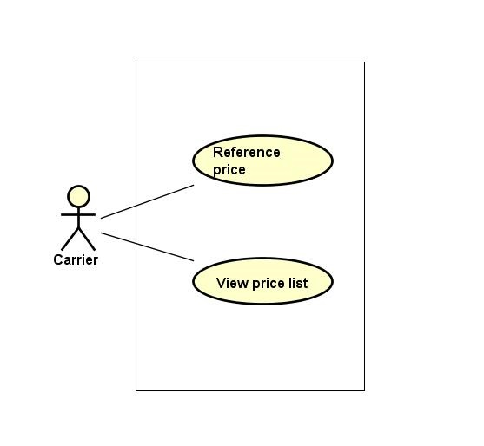

Figure ‑: Manage price list group function

##### Reference price

|  |  |  |  |  |
| --- | --- | --- | --- | --- |
| **Created by:** | | QuyetTD | **Date Created:** | 08/03/2017 |
| **Primary Actor** | | Carrier | **Secondary Actor** |  |
| **Description:** | | Carrier want to reference actual price system updated | | |
| **Preconditions:** | | 1. “Tham Chiếu” item appear on header of website 2. “BÁO GIÁ” navigator appear on header of website | | |
| **Trigger:** | | “Tham chiếu” item is clicked | | |
| **Post conditions:** | | Display price list on price list page | | |
| **Normal Flow** | | | | |
| **Step** | **Actor** | **Action** | | |
| 1 | CRE | Click “Tham chiếu” button | | |
| 2 | CTC | Display price list from other website | | |
| **Alternative Flows: N/A** | | | | |
| **Exceptions: N/A** | | | | |
| **Priority** | | Medium | | |
| **Frequency of Use:** | | Medium | | |
| **Business Rules:** | | N/A | | |
| **Other Information:** | | N/A | | |

Table ‑: Reference price

##### View price list

|  |  |  |  |  |
| --- | --- | --- | --- | --- |
| **Created by:** | | QuyetTD | **Date Created:** | 08/03/2017 |
| **Primary Actor** | | Carrier | **Secondary Actor** |  |
| **Description:** | | CRE want to view list of price | | |
| **Preconditions:** | | 1. “Hệ Thống” item appear on header of website 2. “BÁO GIÁ” navigator appear on header of website | | |
| **Trigger:** | | “Hệ Thống” item is clicked | | |
| **Post conditions:** | | Display price list on price list page | | |
| **Normal Flow** | | | | |
| **Step** | **Actor** | **Action** | | |
| 1 | CRE | Click “Báo Giá” navigator and then choose “Hệ Thống” item | | |
| 2 | CTC | Display price list on price list page | | |
| **Alternative Flows:** N/A | | | | |
| **Exceptions: N/A** | | | | |
| **Priority** | | High | | |
| **Frequency of Use:** | | High | | |
| **Business Rules:** | | N/A | | |
| **Other Information:** | | N/A | | |

Table ‑: View report list

#### Connect to goods owner group function

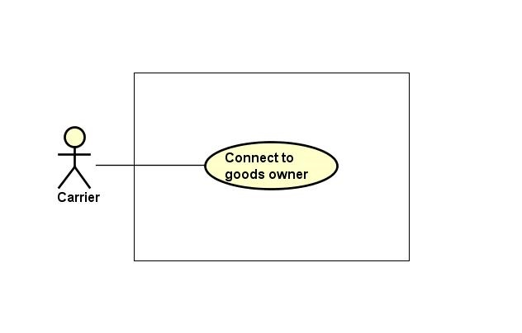

Figure ‑: Connect to goods owner group function

##### Connect to goods owner

|  |  |  |  |  |
| --- | --- | --- | --- | --- |
| **Created by:** | | QuyetTD | **Date Created:** | 08/03/2017 |
| **Primary Actor** | | Carrier | **Secondary Actor** |  |
| **Description:** | | Carrier want to connect to Goods owner | | |
| **Preconditions:** | | Bill of lading is successful | | |
| **Trigger:** | | “Reply” item on bill of lading detail page is clicked | | |
| **Post conditions:** | | Send comment to goods owner | | |
| **Normal Flow** | | | | |
| **Step** | **Actor** | **Action** | | |
| 1 | CRE | Click “Chi Tiết” on a bill of lading | | |
| 2 | CTC | Display bill of lading detail comment includes:   * “Hỏi Đáp” input text | | |
| 3 | CRE | Enter data in fields | | |
| 4 | CRE | Press enter key word on keyboard | | |
| 5 | CTC | Send comment to goods owner | | |
| **Alternative Flows:** | | | | |
| **AT1** | At step 4 in the main flows, if CRE click other hyperlinks or buttons | | | |
| **Step** | **Actor** | **Action** | | |
| 5.1 | CTC | Redirects CRE to chosen hyperlink or button | | |
| **Exceptions: N/A** | | | | |
| **Priority** | | Medium | | |
| **Frequency of Use:** | | Medium | | |
| **Business Rules:** | | B14 | | |
| **Other Information:** | | N/A | | |

Table ‑: Connect to goods owner

#### Transaction history group function

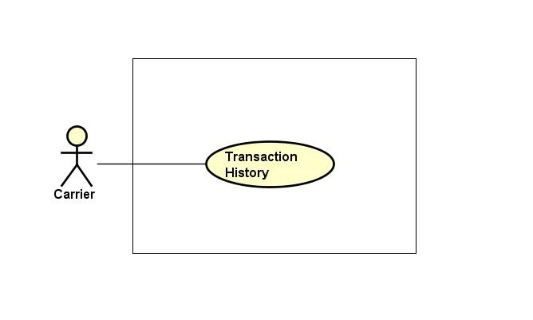

Figure ‑: Transaction history group function

##### Transaction history

|  |  |  |  |  |
| --- | --- | --- | --- | --- |
| **Created by:** | | QuyetTD | **Date Created:** | 08/03/2017 |
| **Primary Actor** | | Carrier | **Secondary Actor** |  |
| **Description:** | | Carrier want to check money in account and what did they do with money | | |
| **Preconditions:** | | “Thông tin giao dịch” item appear on top navigator | | |
| **Trigger:** | | “Thông tin giao dịch” item is clicked | | |
| **Post conditions:** | | Display money in account and transaction history | | |
| **Normal Flow** | | | | |
| **Step** | **Actor** | **Action** | | |
| 1 | Carrier | Hover mouse to user name and Click “Thông tin giao dịch” item | | |
| 2 | CTC | Display money in account and transaction history | | |
| **Alternative Flows: N/A** | | | | |
| **Exceptions: N/A** | | | | |
| **Priority** | | Medium | | |
| **Frequency of Use:** | | Medium | | |
| **Business Rules:** | | N/A | | |
| **Other Information:** | | N/A | | |

Table ‑: Transaction history

#### Login group function

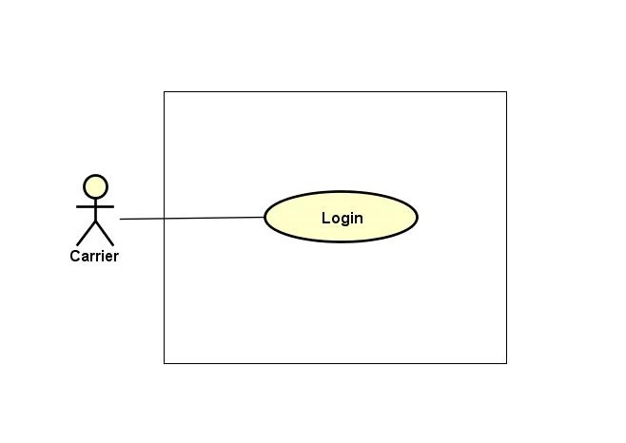

Figure ‑: Login group function

##### Login

|  |  |  |  |  |  |  |
| --- | --- | --- | --- | --- | --- | --- |
| **Created by:** | | | QuyetTD | | **Date Created:** | 08/03/2017 |
| **Primary Actor** | | | Carrier | | **Secondary Actor** |  |
| **Description:** | | | CRE want to login to CTC system for work | | | |
| **Preconditions:** | | | “Đăng nhập” button appear on login page | | | |
| **Trigger:** | | | “Đăng nhập” button on login page is clicked | | | |
| **Post conditions:** | | | Carrier login to CTC system | | | |
| **Normal Flow** | | | | | | |
| **Step** | **Actor** | | **Action** | | | |
| 1 | CRE | | Click “Đăng nhập” on homepage | | | |
| 2 | CTC | | Display login page includes:   * “Email” input text * “Mật khẩu” input text * “Đăng nhập” button | | | |
| 3 | CRE | | Enter data in fields | | | |
| 4 | CTC | | Login account to CTC | | | |
| **Alternative Flows: N/A** | | | | | | |
| **Exceptions:** | | | | | | |
| **EC1** | | At step 4, required fields are not entered | | | | |
| **Step** | | **Actor** | | **Action** | | |
| 4.1 | | CTC | | Display Register page with message error | | |
| 4.2 | | CTC | | Mark error fields | | |
| **EC2** | | At step 4, fields are entered with wrong type of data | | | | |
| **Step** | | **Actor** | | **Action** | | |
| 4.1 | | CTC | | Display Register page with message error | | |
| 4.2 | | CTC | | Mark error fields | | |
| **Priority** | | | High | | | |
| **Frequency of Use:** | | | High | | | |
| **Business Rules:** | | | B2, B11 | | | |
| **Other Information:** | | | N/A | | | |

Table ‑: Login

#### Logout group function

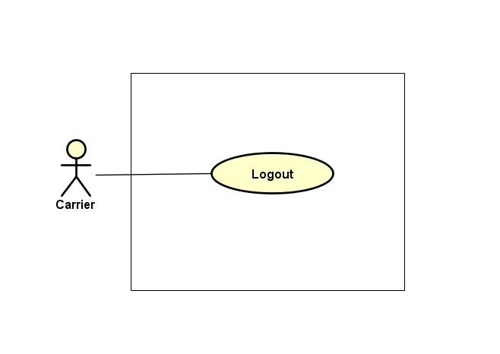

Figure ‑: Logout group function

##### Logout

|  |  |  |  |  |
| --- | --- | --- | --- | --- |
| **Created by:** | | QuyetTD | **Date Created:** | 08/03/2017 |
| **Primary Actor** | | Carrier | **Secondary Actor** |  |
| **Description:** | | CRE want to logout CTC system | | |
| **Preconditions:** | | “Đăng xuất” button appear on top navigator | | |
| **Trigger:** | | “Đăng xuất” button is clicked | | |
| **Post conditions:** | | Logout carrier account | | |
| **Normal Flow** | | | | |
| **Step** | **Actor** | **Action** | | |
| 1 | CRE | Click “Đăng xuất” in website | | |
| 2 | CTC | Logout Goods owner account | | |
| 3 | CTC | Return homepage | | |
| **Alternative Flows: N/A** | | | | |
| **Exceptions: N/A** | | | | |
| **Priority** | | High | | |
| **Frequency of Use:** | | High | | |
| **Business Rules:** | | N/A | | |
| **Other Information:** | | N/A | | |

Table ‑: Logout

### **Goods Owner Group Function**

#### Bill of lading list group function

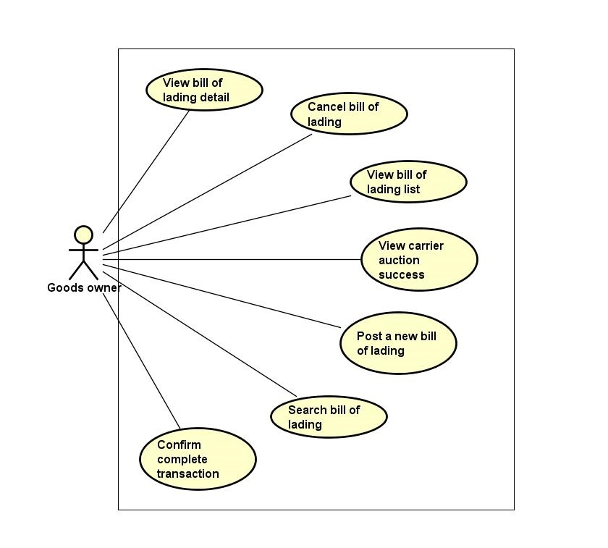

Figure ‑: Bill of lading list group function

##### View bill of lading list

|  |  |  |  |  |
| --- | --- | --- | --- | --- |
| **Created by:** | | QuyetTD | **Date Created:** | 08/03/2017 |
| **Primary Actor** | | Goods owner | **Secondary Actor** |  |
| **Description:** | | User want to view all bill of lading | | |
| **Preconditions:** | | “Tìm Hàng Chuyển” navigator appear on header of website | | |
| **Trigger:** | | “Tìm Hàng Chuyển” navigator is clicked | | |
| **Post conditions:** | | Display bill of lading list on common page | | |
| **Normal Flow** | | | | |
| **Step** | **Actor** | **Action** | | |
| 1 | GWN | Click “Tìm Hàng Chuyển” navigator | | |
| 2 | CTC | Display bill of lading list on bill of lading list page | | |
| **Alternative Flows: N/A** | | | | |
| **Exceptions: N/A** | | | | |
| **Priority** | | Medium | | |
| **Frequency of Use:** | | High | | |
| **Business Rules:** | | N/A | | |
| **Other Information:** | | N/A | | |

Table ‑: View bill of lading list

##### Confirm complete transaction

|  |  |  |  |  |
| --- | --- | --- | --- | --- |
| **Created by:** | | QuyetTD | **Date Created:** | 08/03/2017 |
| **Primary Actor** | | Goods owner | **Secondary Actor** |  |
| **Description:** | | Goods owner want to confirm that they are complete bill of lading to the system. It means that their customer got goods. They will get down payment back | | |
| **Preconditions:** | | 1. CTC must be connected to the Internet 2. GWN browsed CTC website 3. Go to bill of lading detail | | |
| **Trigger:** | | Click “Hoàn thành giao dịch” button in bill of lading detail page | | |
| **Post conditions:** | | Return down payment of customer to account and update bill of lading detail page | | |
| **Normal Flow** | | | | |
| **Step** | **Actor** | **Action** | | |
| 1 | GWN | Click “Hoàn thành giao dịch” button | | |
| 2 | CTC | Display bill of lading detail page update | | |
| **Alternative Flows: N/A** | | | | |
| **Exceptions: N/A** | | | | |
| **Priority** | | Medium | | |
| **Frequency of Use:** | | Medium | | |
| **Business Rules:** | | B14 | | |
| **Other Information:** | | N/A | | |

Table ‑: Confirm complete transaction

##### View bill of lading detail

|  |  |  |  |  |
| --- | --- | --- | --- | --- |
| **Created by:** | | QuyetTD | **Date Created:** | 08/03/2017 |
| **Primary Actor** | | Goods owner | **Secondary Actor** |  |
| **Description:** | | GWN want to view bill of lading detail, they send request to system and then get result | | |
| **Preconditions:** | | 1. “Tìm Hàng Chuyển” navigator appear on homepage 2. Detail icon appear on bill of lading detail page | | |
| **Trigger:** | | Detail icon of bill of lading is clicked | | |
| **Post conditions:** | | Display bill of lading detail on bill of lading detail page | | |
| **Normal Flow** | | | | |
| **Step** | **Actor** | **Action** | | |
| 1 | GWN | Click “Tim Hàng Vận Chuyển” navigator | | |
| 2 | CTC | Display bill of lading list page | | |
| 3 | GWN | Click “Chi Tiết” on bill of lading | | |
| 4 | CTC | Display bill of lading detail on bill of lading detail page | | |
| **Alternative Flows: N/A** | | | | |
| **Exceptions: N/A** | | | | |
| **Priority** | | High | | |
| **Frequency of Use:** | | High | | |
| **Business Rules:** | | B33 | | |
| **Other Information:** | | N/A | | |

Table ‑: View bill of lading detail

##### Cancel bill of lading

|  |  |  |  |  |
| --- | --- | --- | --- | --- |
| **Created by:** | | QuyetTD | **Date Created:** | 08/03/2017 |
| **Primary Actor** | | Goods owner | **Secondary Actor** |  |
| **Description:** | | Goods owner do not want to transport their goods. So they cancel bill of lading | | |
| **Preconditions:** | | Cancel button appear on bill of lading detail page | | |
| **Trigger:** | | “Hủy Đấu Giá” button is clicked | | |
| **Post conditions:** | | Bill of lading will be disable | | |
| **Normal Flow** | | | | |
| **Step** | **Actor** | **Action** | | |
| 1 | GWN | Click “Hủy Đấu Giá” button | | |
| 2 | CTC | Cancel bill of lading | | |
| 3 | CTC | Update bill of lading detail page | | |
| **Alternative Flows: N/A** | | | | |
| **Exceptions: N/A** | | | | |
| **Priority** | | High | | |
| **Frequency of Use:** | | High | | |
| **Business Rules:** | | N/A | | |
| **Other Information:** | | N/A | | |

Table ‑: Cancel bill of lading

##### Search bill of lading

|  |  |  |  |  |
| --- | --- | --- | --- | --- |
| **Created by:** | | QuyetTD | **Date Created:** | 08/03/2017 |
| **Primary Actor** | | Goods owner | **Secondary Actor** |  |
| **Description:** | | GWN want to find a bill of lading | | |
| **Preconditions:** | | 1. “Tìm Hàng Chuyển” navigator appear on header of website 2. Search box appear on common page | | |
| **Trigger:** | | “Tìm Hàng Chuyển” navigator is clicked | | |
| **Post conditions:** | | Display bill of lading system found on common page | | |
| **Normal Flow** | | | | |
| **Step** | **Actor** | **Action** | | |
| 1 | GWN | Click “Tìm Hàng Chuyển” navigator one website | | |
| 2 | CTC | Display summary bill of lading page includes:   * “Loại hàng select box * “Hình thức đóng gói” select box * “Khối lượng” input text * “Thể tích” input text * “Địa điểm đi” select box * “Địa điểm đến” select box * “Thời gian đi” Date picker * “Thời gian đến” Date picker * “Tìm Kiếm” buttons | | |
| 3 | GWN | Enter data in this fields | | |
| 4 | GWN | Click “Tìm Kiếm” button search page | | |
| 5 | CTC | Display bill of lading system found on common page | | |
| **Alternative Flows:** | | | | |
| **AT1** | At step 4 in the main flows, if GWN click other hyperlinks or buttons | | | |
| **Step** | **Actor** | **Action** | | |
| 5.1 | CTC | Redirects GWN to chosen hyperlink or button | | |
| **Exceptions: N/A** | | | | |
| **Priority** | | High | | |
| **Frequency of Use:** | | High | | |
| **Business Rules:** | | N/A | | |
| **Other Information:** | | N/A | | |

Table ‑: Search bill of lading

##### View carrier auction success

|  |  |  |  |  |
| --- | --- | --- | --- | --- |
| **Created by:** | | QuyetTD | **Date Created:** | 08/03/2017 |
| **Primary Actor** | | Goods owner | **Secondary Actor** |  |
| **Description:** | | GWN want to view who auction bill of lading successful | | |
| **Preconditions:** | | 1. Bill of lading is successful 2. Detail icon of bill of lading appear bill of lading detail page | | |
| **Trigger:** | | Detail icon of bill of lading appear bill of lading detail page is clicked | | |
| **Post conditions:** | | Display who are auction success on bill of lading detail page | | |
| **Normal Flow** | | | | |
| **Step** | **Actor** | **Action** | | |
| 1 | GWN | Click “GIAO DỊCH CỦA TÔI” navigator | | |
| 2 | CTC | Display bill of lading list page | | |
| 3 | GWN | Click detail icon of bill of lading on Goods Owner Bill Of Lading page | | |
| 4 | CTC | Display who are auction success on detail page | | |
| **Alternative Flows: N/A** | | | | |
| **Exceptions: N/A** | | | | |
| **Priority** | | Medium | | |
| **Frequency of Use:** | | Medium | | |
| **Business Rules:** | | B33 | | |
| **Other Information:** | | N/A | | |

Table ‑: View carrier auction success

##### Post a new bill of lading

|  |  |  |  |  |  |  |
| --- | --- | --- | --- | --- | --- | --- |
| **Created by:** | | | QuyetTD | | **Date Created:** | 08/03/2017 |
| **Primary Actor** | | | Goods owner | | **Secondary Actor** |  |
| **Description:** | | | Goods owner want to transport their goods so create a new bill of lading in CTC system | | | |
| **Preconditions:** | | | “TẠO VẬN ĐƠN” navigator appear on header of website | | | |
| **Trigger:** | | | “TẠO VẬN ĐƠN” navigator is clicked | | | |
| **Post conditions:** | | | Register new bill of lading in CTC system | | | |
| **Normal Flow** | | | | | | |
| **Step** | **Actor** | | **Action** | | | |
| 1 | GWN | | Click “Tạo Vận Đơn” navigator | | | |
| 2 | CTC | | Display post bill of lading page includes:   * “Mã vận đơn” input text * “loại hàng” select box * “Hình thức đóng gói” select box * “Họ tên người gửi” input text * “Số điện thoại” input text * “Họ tên người nhận” input text * “Địa điểm gửi” select box * “Địa điểm nhận” select box * “Từ quận/huyện” select box * “Đến quận/huyện” select box * “Địa chỉ nơi gửi” input text * “Địa chỉ nơi nhận” input text * “Đặc điểm nơi gửi” input text * “Đặc điểm nơi nhận” input text * “Ngày gửi” date time picker * “Ngày nhận” date time picker * “Quãng đường” input text * “Khối lượng” input text * “Số lượng” input text * “Dài” input text * “Rộng” input text * “Cao” input text * “Hàng đông lạnh” check box * “Hàng dễ vỡ” check box * “Hình ảnh” button upload * “Mô tả” ricd texbox * “Giá đề xuất” input text * “Thời gian kết thúc đấu giá” date time picker * “Đăng ký” button * “Hủy bỏ” button | | | |
| 3 | GWN | | Enter data in fields | | | |
| 4 | GWN | | Click “Đăng ký” button on post bill of lading page | | | |
| 5 | CTC | | Save data in database (register bill of lading in database) | | | |
| 6 | CTC | | Display new bill of lading on bill of lading detail | | | |
| **Alternative Flows:** | | | | | | |
| **AT1** | at step 4, GWN click “Hủy bỏ” button | | | | | |
| **Step** | **Actor** | | **Action** | | | |
| 6.1 | CTC | | Return bill of lading list page | | | |
| **AT2** | At step 4 in the main flows, if GWN click other hyperlinks or buttons | | | | | |
| **Step** | **Actor** | | **Action** | | | |
| 6.1 | CTC | | Redirects GWN to chosen hyperlink or button | | | |
| **Exceptions:** | | | | | | |
| **EC1** | | At step 4, required fields are not entered | | | | |
| **Step** | | **Actor** | | **Action** | | |
| 4.1 | | CTC | | Display Register page with message error | | |
| 4.2 | | CTC | | Mark error fields | | |
| **EC2** | | At step 4, fields are entered with wrong type of data | | | | |
| **Step** | | **Actor** | | **Action** | | |
| 4.1 | | CTC | | Display Register page with message error | | |
| 4.2 | | CTC | | Mark error fields | | |
| **Priority** | | | High | | | |
| **Frequency of Use:** | | | High | | | |
| **Business Rules:** | | | B4, B21, B34, B35, B36, B37, B38, B39, B40, B41, B42, B43, B44, B45, B46, B47, B48, B49, B50 | | | |
| **Other Information:** | | | N/A | | | |

Table ‑: Post bill of lading

#### Price list group function

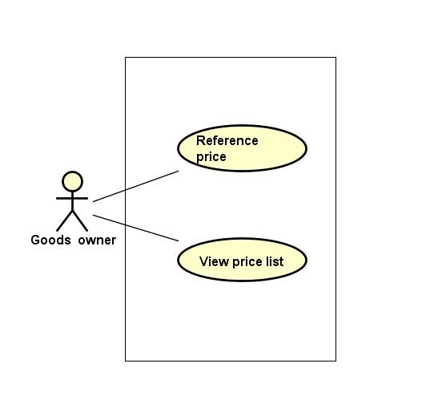

Figure ‑: Price list group function

##### View price list

|  |  |  |  |  |
| --- | --- | --- | --- | --- |
| **Created by:** | | QuyetTD | **Date Created:** | 08/03/2017 |
| **Primary Actor** | | Goods owner | **Secondary Actor** |  |
| **Description:** | | Goods owner want to view list of price | | |
| **Preconditions:** | | 1. “Hệ Thống” item appear on header of website 2. “BÁO GIÁ” navigator appear on header of website | | |
| **Trigger:** | | “Hệ Thống” item is clicked | | |
| **Post conditions:** | | Display price list on price list page | | |
| **Normal Flow** | | | | |
| **Step** | **Actor** | **Action** | | |
| 1 | GWN | Click “Báo Giá” navigator and then choose “Hệ Thống” | | |
| 2 | CTC | Display price list on price list page | | |
| **Exceptions: N/A** | | | | |
| **Priority** | | High | | |
| **Frequency of Use:** | | High | | |
| **Business Rules:** | | N/A | | |
| **Other Information:** | | N/A | | |

Table ‑: View price list

##### Reference price

|  |  |  |  |  |
| --- | --- | --- | --- | --- |
| **Created by:** | | QuyetTD | **Date Created:** | 08/03/2017 |
| **Primary Actor** | | Goods owner | **Secondary Actor** |  |
| **Description:** | | Goods owner want to reference actual price system updated | | |
| **Preconditions:** | | 1. “Tham Chiếu” item appear on header of website 2. “BÁO GIÁ” navigator appear on header of website | | |
| **Trigger:** | | “Tham chiếu” item is clicked | | |
| **Post conditions:** | | Display price list on price list page | | |
| **Normal Flow** | | | | |
| **Step** | **Actor** | **Action** | | |
| 1 | GWN | Click “Tham chiếu” item | | |
| 2 | CTC | Display price list from other website | | |
| **Alternative Flows: N/A** | | | | |
| **Exceptions: N/A** | | | | |
| **Priority** | | Medium | | |
| **Frequency of Use:** | | Medium | | |
| **Business Rules:** | | N/A | | |
| **Other Information:** | | N/A | | |

Table ‑: Reference price

#### Manage report group function

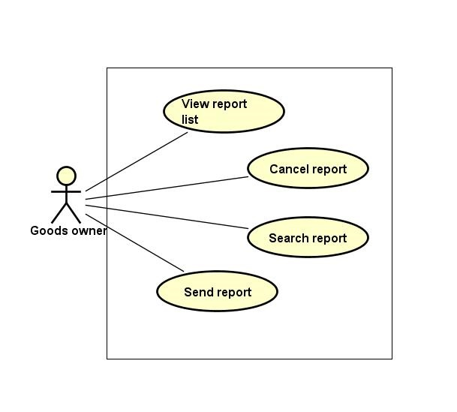

Figure ‑: Manage report group function

##### Send report

|  |  |  |  |  |  |  |
| --- | --- | --- | --- | --- | --- | --- |
| **Created by:** | | | QuyetTD | | **Date Created:** | 08/03/2017 |
| **Primary Actor** | | | Goods owner | | **Secondary Actor** |  |
| **Description:** | | | Goods owner want to send report to admin | | | |
| **Preconditions:** | | | 1. “BÁO CÁO CỦA TÔI” navigator appear on header of website 2. “Tạo báo cáo mới” button appear on list report user page | | | |
| **Trigger:** | | | “Tạo mới báo cáo” button is clicked | | | |
| **Post conditions:** | | | Send report to admin | | | |
| **Normal Flow** | | | | | | |
| **Step** | **Actor** | | **Action** | | | |
| 1 | GWN | | Click “Tạo mới báo cáo” button | | | |
| 2 | CTC | | Display add new report page includes:   * “Chủ đề bạn muốn báo cáo là gì” input text * “Câu hỏi của bạn là gì” input text * “Bạn mong muốn xử lý như thế nào” input text * “Nội dung báo cáo của bạn” input text * “Gửi phản hồi” button * “Quay lại” button | | | |
| 3 | GWN | | Enter data in fields | | | |
| 4 | GWN | | Click “Gửi phản hồi” button | | | |
| 5 | CTC | | Send report to admin | | | |
| **Alternative Flows:** | | | | | | |
| **AT1** | At step 4, GWN click “Quay lại” button | | | | | |
| **Step** | **Actor** | | **Action** | | | |
| 5.1 | CTC | | Return report list page | | | |
| **AT2** | At step 4 in the main flows, if GWN click other hyperlinks or buttons | | | | | |
| **Step** | **Actor** | | **Action** | | | |
| 5.1 | CTC | | Redirects GWN to chosen hyperlink or button | | | |
| **Exceptions:** | | | | | | |
| **EC1** | | At step 3, required fields are not entered | | | | |
| **Step** | | **Actor** | | **Action** | | |
| 5.1 | | CTC | | Display Register page with message error | | |
| 5.2 | | CTC | | Mark error fields | | |
| **Priority** | | | Medium | | | |
| **Frequency of Use:** | | | Medium | | | |
| **Business Rules:** | | | N/A | | | |
| **Other Information:** | | | N/A | | | |

Table ‑: Send report

##### View report list

|  |  |  |  |  |
| --- | --- | --- | --- | --- |
| **Created by:** | | QuyetTD | **Date Created:** | 08/03/2017 |
| **Primary Actor** | | Goods owner | **Secondary Actor** |  |
| **Description:** | | GWN want to view report list | | |
| **Preconditions:** | | “BÁO CÁO CỦA TÔI” navigator appear on header of website | | |
| **Trigger:** | | “BÁO CÁO CỦA TÔI” navigator is clicked | | |
| **Post conditions:** | | Display report list on report list page | | |
| **Normal Flow** | | | | |
| **Step** | **Actor** | **Action** | | |
| 1 | GWN | Click “Báo Cáo Của Tôi” navigator | | |
| 2 | CTC | Display report list on report list page | | |
| **Alternative Flows: N/A** | | | | |
| **Exceptions: N/A** | | | | |
| **Priority** | | Medium | | |
| **Frequency of Use:** | | High | | |
| **Business Rules:** | | N/A | | |
| **Other Information:** | | N/A | | |

Table ‑: View report list

##### Search report

|  |  |  |  |  |  |  |
| --- | --- | --- | --- | --- | --- | --- |
| **Created by:** | | | QuyetTD | | **Date Created:** | 08/03/2017 |
| **Primary Actor** | | | Goods owner | | **Secondary Actor** |  |
| **Description:** | | | Goods owner want to find a report in report list | | | |
| **Preconditions:** | | | 1. “BÁO CÁO CỦA TÔI” navigator appear header of website 2. Search box appear on list report user page | | | |
| **Trigger:** | | | “BÁO CÁO CỦA TÔI” navigator appear header of website | | | |
| **Post conditions:** | | | Display report on report list page | | | |
| **Normal Flow** | | | | | | |
| **Step** | **Actor** | | **Action** | | | |
| 1 | GWN | | GWN click “Quản Lý Report” navigator | | | |
| 2 | CTC | | Display search page includes:   * “Tên tài khoản” * “Tên người dung” * “Tiêu đề báo cáo” * “Tìm kiếm” button * “ngày bắt đầu” input text * “ngày kết thúc” input text | | | |
| 3 | GWN | | Enter data in fields | | | |
| 4 | GWN | | Click “Tìm kiếm” button | | | |
| 5 | CTC | | Display result on report list page | | | |
| **Alternative Flows:** | | | | | | |
| **AT1** | | At step 4 in the main flows, if GWN click other hyperlinks or buttons | | | | |
| **Step** | | **Actor** | | **Action** | | |
| 5.1 | | CTC | | Redirects GWN to chosen hyperlink or button | | |
| **Exceptions: N/A** | | | | | | |
| **Priority** | | | Medium | | | |
| **Frequency of Use:** | | | Medium | | | |
| **Business Rules:** | | | N/A | | | |
| **Other Information:** | | | N/A | | | |

Table ‑: Search report

##### Cancel report

|  |  |  |  |  |
| --- | --- | --- | --- | --- |
| **Created by:** | | QuyetTD | **Date Created:** | 08/03/2017 |
| **Primary Actor** | | Goods owner | **Secondary Actor** |  |
| **Description:** | | GWN want to cancel their report | | |
| **Preconditions:** | | “BÁO CÁO CỦA TÔI” navigator appear on header of website | | |
| **Trigger:** | | “BÁO CÁO CỦA TÔI” navigator is clicked | | |
| **Post conditions:** | | Cancel this report | | |
| **Normal Flow** | | | | |
| **Step** | **Actor** | **Action** | | |
| 1 | GWN | Click “Báo Cáo Của Tôi” navigator | | |
| 2 | GWN | Click cancel report icon | | |
| 2 | CTC | Cancel this report | | |
| **Alternative Flows: N/A** | | | | |
| **Exceptions: N/A** | | | | |
| **Priority** | | Medium | | |
| **Frequency of Use:** | | High | | |
| **Business Rules:** | | N/A | | |
| **Other Information:** | | N/A | | |

#### Manage profile group function

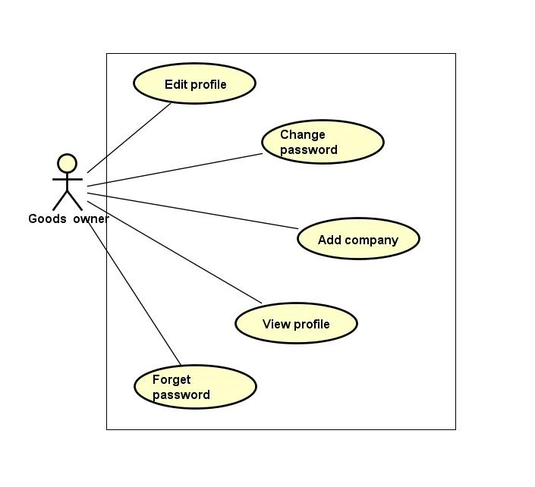

Figure ‑: Manage profile group function

##### Edit profile

|  |  |  |  |  |
| --- | --- | --- | --- | --- |
| **Created by:** | | QuyetTD | **Date Created:** | 08/03/2017 |
| **Primary Actor** | | Goods owner | **Secondary Actor** |  |
| **Description:** | | Goods owner want to edit goods owner profile | | |
| **Preconditions:** | | “Thay Đổi” button appear on detail user view page | | |
| **Trigger:** | | “Thay Đổi” button on detail user view page is clicked | | |
| **Post conditions:** | | Save goods owner profile in database | | |
| **Normal Flow** | | | | |
| **Step** | **Actor** | **Action** | | |
| 1 | GWN | Hover mouser to user name label and clicj “Chỉnh Sửa Thông Tin” item | | |
| 2 | CTC | Display pop-up includes:   * “Chọn ảnh” file chooser * “Họ tên” input text * “Bạn là” (phân quyền quản trị) check box * “Email” input text * “Địa chỉ” input text * “Chứng minh thư” input text * “Ngày cấp thẻ” date picker * “Ngày tham gia” date picker * “Thay Đổi” button | | |
| 3 | GWN | Change data in this fields | | |
| 4 | GWN | Click “Lưu Thay Đổi” button | | |
| 5 | CTC | Save changed in database | | |
| 6 | CTC | Display changed on user detail page | | |
| **Alternative Flows:** | | | | |
| **AT1** | At step 4, GWN click “x” in pop-up | | | |
| **Step** | **Actor** | **Action** | | |
| 4.1 | GWN | click “x” in pop-up | | |
| 6.1 | CTC | Display user detail page | | |
| **AT2** | At step 4 in the main flows, if GWN click other hyperlinks or buttons | | | |
| **Step** | **Actor** | **Action** | | |
| 6.1 | CTC | Redirects GWN to chosen hyperlink or button | | |
| **Exceptions: N/A** | | | | |
| **Priority** | | Medium | | |
| **Frequency of Use:** | | Medium | | |
| **Business Rules:** | | N/A | | |
| **Other Information:** | | N/A | | |

Table ‑: Edit profile

##### Change password

|  |  |  |  |  |  |  |
| --- | --- | --- | --- | --- | --- | --- |
| **Created by:** | | | QuyetTD | | **Date Created:** | 08/03/2017 |
| **Primary Actor** | | | Goods owner | | **Secondary Actor** |  |
| **Description:** | | | GWN want to change their password for security | | | |
| **Preconditions:** | | | “Thay đổi mật khẩu” item appear on top navigator | | | |
| **Trigger:** | | | “Thay đổi mật khẩu” item is clicked | | | |
| **Post conditions:** | | | Change password of goods owner | | | |
| **Normal Flow** | | | | | | |
| **Step** | **Actor** | | **Action** | | | |
| 1 | GWN | | Hover mouse to user name label and click “Đổi mật khẩu” item | | | |
| 2 | CTC | | Display change password page includes:   * “Mật khẩu cũ” input text * “Mật khẩu mới” input text * “Xác nhận mật khẩu” input text * “Đổi mật khẩu” button | | | |
| 3 | GWN | | Enter data in this fields | | | |
| 4 | GWN | | Click “Đổi mật khẩu” button | | | |
| 5 | CTC | | Save new password in database | | | |
| 6 | CTC | | Display “Thay đổi thành công” message on pop-up | | | |
| **Alternative Flows: N/A** | | | | | | |
| **AT1** | At step 4 in the main flows, if GWN click other hyperlinks or buttons | | | | | |
| **Step** | **Actor** | | **Action** | | | |
| 6.1 | CTC | | Redirects GWN to chosen hyperlink or button | | | |
| **Exceptions:** | | | | | | |
| **EC1** | | At step 3, required fields are not entered | | | | |
| **Step** | | **Actor** | | **Action** | | |
| 6.1 | | CTC | | Display Register page with message error | | |
| 6.2 | | CTC | | Mark error fields | | |
| **EC2** | | At step 3, fields are entered with wrong type of data | | | | |
| **Step** | | **Actor** | | **Action** | | |
| 6.1 | | CTC | | Display Register page with message error | | |
| 6.2 | | CTC | | Mark error fields | | |
| **EC3** | | At step 3, password is wrong | | | | |
| **Step** | | **Actor** | | **Action** | | |
| 6.1 | | CTC | | Display Register page with message error | | |
| 6.2 | | CTC | | Mark error fields | | |
| **EC4** | | At step 3, new password and confirm password are not match | | | | |
| **Step** | | **Actor** | | **Action** | | |
| 6.1 | | CTC | | Display Register page with message error | | |
| 6.2 | | CTC | | Mark error fields | | |
| **Priority** | | | Medium | | | |
| **Frequency of Use:** | | | Medium | | | |
| **Business Rules:** | | | B12, B15 | | | |
| **Other Information:** | | | N/A | | | |

Table ‑: Change password

##### Add company

|  |  |  |  |  |  |
| --- | --- | --- | --- | --- | --- |
| **Created by:** | | | QuyetTD | **Date Created:** | 08/03/2017 |
| **Primary Actor** | | | Goods owner | **Secondary Actor** |  |
| **Description:** | | | Goods owner want to add company information to their profile. | | |
| **Preconditions:** | | | “Thêm mới” button appear below “THÔNG TIN CÔNG TY” label | | |
| **Trigger:** | | | “Thêm mới” button on view user detail page is cliecked | | |
| **Post conditions:** | | | Add company information to user | | |
| **Normal Flow** | | | | | |
| **Step** | **Actor** | | **Action** | | |
| 1 | GWN | | Click “Thêm thông tin công ty” button on view user detail page | | |
| 2 | CTC | | Display add company information for user pop-up includes:   * “Tên công ty” input text * “Email” input text * “Số điện thoại” input text * “Fax” input text * “Địa chỉ” input text * “Mã số thuế” input text * “Hủy bỏ” button | | |
| 3 | GWN | | * Enter data on fields * Click “Xác nhận” button | | |
| 4 | CTC | | * Add company information for user | | |
| **Alternative Flows: N/A** | | | | | |
| **AT1** | At step 3 in the main flows, GWN click “Hủy bỏ” button | | | | |
| **Step** | **Actor** | | **Action** | | |
| 4.1 | CTC | | Close “Thêm thông tin công ty” pop-up | | |
| **Exceptions: N/A** | | | | | |
| **EC1** | | At step 3, required fields are not entered | | | |
| **Step** | | **Actor** | **Action** | | |
| 6.1 | | CTC | Display Register page with message error | | |
| 6.2 | | CTC | Mark error fields | | |
| **EC2** | | At step 3, fields are entered with wrong type of data | | | |
| **Step** | | **Actor** | **Action** | | |
| 6.1 | | CTC | Display Register page with message error | | |
| 6.2 | | CTC | Mark error fields | | |
| **Priority** | | | Medium | | |
| **Frequency of Use:** | | | Medium | | |
| **Business Rules:** | | | N/A | | |
| **Other Information:** | | | N/A | | |

Table ‑: Add company

##### Forget password

|  |  |  |  |  |
| --- | --- | --- | --- | --- |
| **Created by:** | | QuyetTD | **Date Created:** | 08/03/2017 |
| **Primary Actor** | | Goods owner | **Secondary Actor** |  |
| **Description:** | | Goods owner forget password. They want to reset password | | |
| **Preconditions:** | | “Quên mật khẩu” label appear on login page | | |
| **Trigger:** | | “Quên mật khẩu” label on login page is clicked | | |
| **Post conditions:** | | System send new password to goods owner’s email | | |
| **Normal Flow** | | | | |
| **Step** | **Actor** | **Action** | | |
| 1 | GWN | GWN click “Quên mật khẩu” on login page | | |
| 2 | CTC | Display forget password page includes:   * “Email đăng ký” input text * “Gửi” button | | |
| 3 | GWN | Enter email address they use for register goods owner account | | |
| 4 | CTC | Send new password to goods owner’s email address | | |
| **Alternative Flows: N/A** | | | | |
| **Exceptions: N/A** | | | | |
| **Priority** | | Medium | | |
| **Frequency of Use:** | | High | | |
| **Business Rules:** | | B22 | | |
| **Other Information:** | | N/A | | |

Table ‑: Forget password

##### View profile

|  |  |  |  |  |
| --- | --- | --- | --- | --- |
| **Created by:** | | QuyetTD | **Date Created:** | 08/03/2017 |
| **Primary Actor** | | Goods owner | **Secondary Actor** |  |
| **Description:** | | Goods owner want to view admin’s profile | | |
| **Preconditions:** | | “Thông Tin Cá Nhân” item appear on top navigator | | |
| **Trigger:** | | “Thông Tin Cá Nhân” item is clicked | | |
| **Post conditions:** | | Display GWN profile | | |
| **Normal Flow** | | | | |
| **Step** | **Actor** | **Action** | | |
| 1 | GWN | Hover mouse to user name label and click “Thông Tin Cá Nhân” item | | |
| 2 | CTC | Display user detail on user detail page | | |
| **Alternative Flows: N/A** | | | | |
| **Exceptions: N/A** | | | | |
| **Priority** | | Medium | | |
| **Frequency of Use:** | | High | | |
| **Business Rules:** | | N/A | | |
| **Other Information:** | | N/A | | |

Table ‑: View profile

#### Transaction history group function

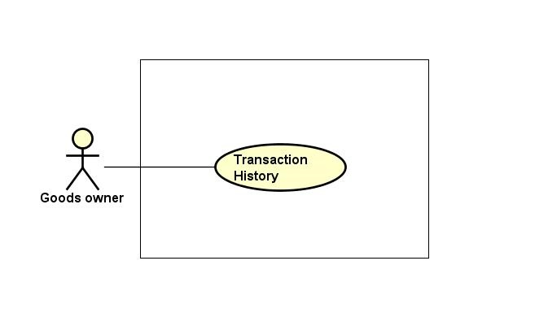

Figure ‑: Transaction group function

##### Transaction history

|  |  |  |  |  |
| --- | --- | --- | --- | --- |
| **Created by:** | | QuyetTD | **Date Created:** | 08/03/2017 |
| **Primary Actor** | | Goods owner | **Secondary Actor** |  |
| **Description:** | | Goods owner want to check money in account and what did they do with money | | |
| **Preconditions:** | | “Thông tin giao dịch” item appear on top navigator | | |
| **Trigger:** | | “Thông tin giao dịch” item is clicked | | |
| **Post conditions:** | | Display money in account and transaction history | | |
| **Normal Flow** | | | | |
| **Step** | **Actor** | **Action** | | |
| 1 | GWN | Hover mouse to user name and Click “Thông tin giao dịch” item | | |
| 2 | CTC | Display money in account and transaction history | | |
| **Alternative Flows: N/A** | | | | |
| **Exceptions: N/A** | | | | |
| **Priority** | | Medium | | |
| **Frequency of Use:** | | Medium | | |
| **Business Rules:** | | N/A | | |
| **Other Information:** | | N/A | | |

Table ‑: Transaction history

#### Account recharge group function

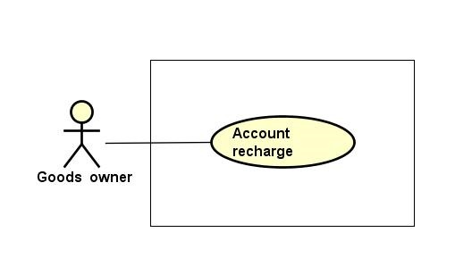

Figure ‑: Account recharge group function

##### Account recharge

|  |  |  |  |  |
| --- | --- | --- | --- | --- |
| **Created by:** | | QuyetTD | **Date Created:** | 08/03/2017 |
| **Primary Actor** | | Goods owner | **Secondary Actor** |  |
| **Description:** | | Goods owner want to account recharge to account for post bill of lading | | |
| **Preconditions:** | | “Nạp tiền vào tài khoản” item appear on top navigator | | |
| **Trigger:** | | “Nạp tiền vào tài khoản” item is clicked | | |
| **Post conditions:** | | Recharge the user account | | |
| **Normal Flow** | | | | |
| **Step** | **Actor** | **Action** | | |
| 1 | GWN | Hover mouse to user name and Click “Nạp tiền vào tài khoản” button | | |
| 2 | CTC | Display “nganluong.vn” website includes 3 item for 3 way to recharge to account:   * “Ví điện thứ Ngân Lượng” button * “Thẻ cào điện thoại” button * “Online bằng thẻ ATM\Internet banking” button * “Chuyển khoản ngân hàng” button | | |
| 3 | GWN | Click one of three button for choose how to recharge to account | | |
| 4 | CTC | Display the way user chose to recharge account | | |
| 5 | GWN | GWN do something follow “Ngân Lượng” guide | | |
| 6 | CTC | Add money to user account | | |
| **Alternative Flows:** | | | | |
| **AT1** | At step 4 in the main flows, if GWN click other hyperlinks or buttons | | | |
| **Step** | **Actor** | **Action** | | |
| 5.1 | CTC | Redirects user to chosen hyperlink or button | | |
| **Exceptions: N/A** | | | | |
| **Priority** | | High | | |
| **Frequency of Use:** | | High | | |
| **Business Rules:** | | N/A | | |
| **Other Information:** | | N/A | | |

Table ‑: Account recharge

#### Connect to carrier group function

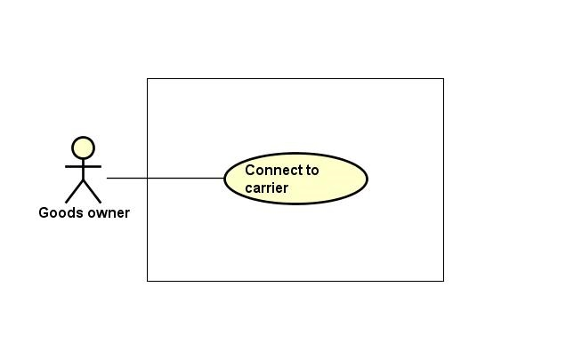

Figure ‑: Connect to carrier group function

##### Connect to carrier

|  |  |  |  |  |
| --- | --- | --- | --- | --- |
| **Created by:** | | QuyetTD | **Date Created:** | 08/03/2017 |
| **Primary Actor** | | Goods owner | **Secondary Actor** |  |
| **Description:** | | Goods owner want to connect to carrier | | |
| **Preconditions:** | | Bill of lading is successful | | |
| **Trigger:** | | “Reply” item on bill of lading detail page is clicked | | |
| **Post conditions:** | | Send comment to carrier | | |
| **Normal Flow** | | | | |
| **Step** | **Actor** | **Action** | | |
| 1 | GWN | Click “Chi Tiết” on a bill of lading | | |
| 2 | CTC | Display bill of lading detail comment includes:   * “Hỏi Đáp” input text | | |
| 3 | GWN | Enter data in fields | | |
| 4 | GWN | Press enter key word on keyboard | | |
| 5 | CTC | Send comment to carrier | | |
| **Alternative Flows:** | | | | |
| **AT1** | At step 4 in the main flows, if GWN click other hyperlinks or buttons | | | |
| **Step** | **Actor** | **Action** | | |
| 5.1 | CTC | Redirects user to chosen hyperlink or button | | |
| **Exceptions: N/A** | | | | |
| **Priority** | | Medium | | |
| **Frequency of Use:** | | Medium | | |
| **Business Rules:** | | B14 | | |
| **Other Information:** | | N/A | | |

Table ‑: Connect to carrier

#### Login group function

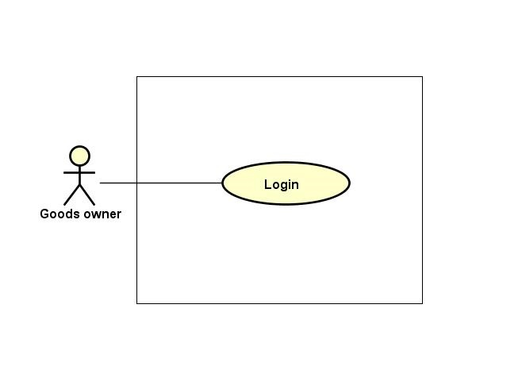

Figure ‑: Login group function

##### Login

|  |  |  |  |  |  |
| --- | --- | --- | --- | --- | --- |
| **Created by:** | | | QuyetTD | **Date Created:** | 08/03/2017 |
| **Primary Actor** | | | Goods owner | **Secondary Actor** |  |
| **Description:** | | | Goods owner want to login to CTC system for work | | |
| **Preconditions:** | | | “Đăng nhập” button appear on login page | | |
| **Trigger:** | | | “Đăng nhập” button on login page is clicked | | |
| **Post conditions:** | | | GWN login to CTC system | | |
| **Normal Flow** | | | | | |
| **Step** | **Actor** | | **Action** | | |
| 1 | GWN | | Click “Đăng nhập” on homepage | | |
| 2 | CTC | | Display login page includes:   * “Email” input text * “Mật khẩu” input text * “Đăng nhập” button | | |
| 3 | GWN | | Enter data in fields | | |
| 4 | CTC | | Login account to CTC | | |
| **Alternative Flows: N/A** | | | | | |
| **Exceptions:** | | | | | |
| **EC1** | | At step 4, required fields are not entered | | | |
| **Step** | | **Actor** | **Action** | | |
| 4.1 | | CTC | Display Register page with message error | | |
| 4.2 | | CTC | Mark error fields | | |
| **EC2** | | At step 4, fields are entered with wrong type of data | | | |
| **Step** | | **Actor** | **Action** | | |
| 4.1 | | CTC | Display Register page with message error | | |
| 4.2 | | CTC | Mark error fields | | |
| **Priority** | | | High | | |
| **Frequency of Use:** | | | High | | |
| **Business Rules:** | | | B2, B11 | | |
| **Other Information:** | | | N/A | | |

Table ‑: Login

#### Logout group function

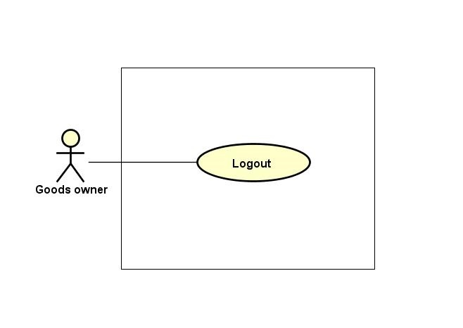

Figure ‑: Logout group function

##### Logout

|  |  |  |  |  |
| --- | --- | --- | --- | --- |
| **Created by:** | | QuyetTD | **Date Created:** | 08/03/2017 |
| **Primary Actor** | | Goods owner | **Secondary Actor** |  |
| **Description:** | | Goods owner want to logout CTC system | | |
| **Preconditions:** | | “Đăng xuất” button appear on top navigator | | |
| **Trigger:** | | “Đăng xuất” button is clicked | | |
| **Post conditions:** | | Logout Goods owner account | | |
| **Normal Flow** | | | | |
| **Step** | **Actor** | **Action** | | |
| 1 | GWN | Click “Đăng xuất” in website | | |
| 2 | CTC | Logout Goods owner account | | |
| 3 | CTC | Return homepage | | |
| **Alternative Flows: N/A** | | | | |
| **Exceptions: N/A** | | | | |
| **Priority** | | High | | |
| **Frequency of Use:** | | High | | |
| **Business Rules:** | | N/A | | |
| **Other Information:** | | N/A | | |

Table ‑: Logout

### **Admin Group Function**

#### Bill of lading list group function

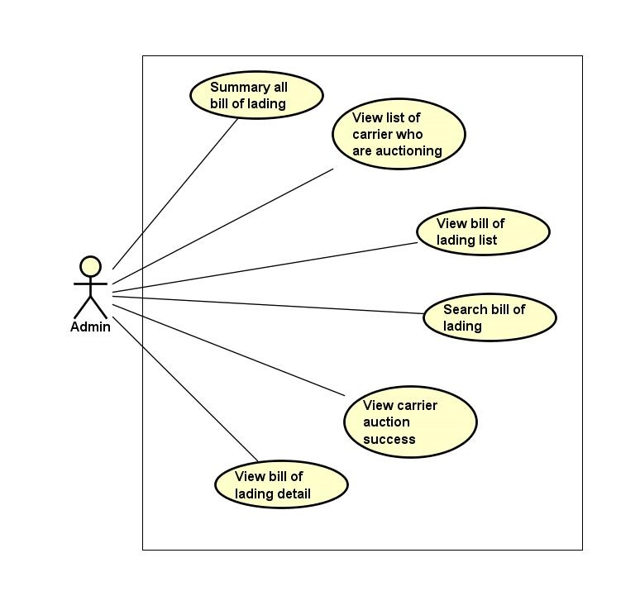

Figure ‑: Bill of lading list group function

##### Summary all bill of lading

|  |  |  |  |  |  |  |
| --- | --- | --- | --- | --- | --- | --- |
| **Created by:** | | | QuyetTD | | **Date Created:** | 08/03/2017 |
| **Primary Actor** | | | Administration | | **Secondary Actor** |  |
| **Description:** | | | Admin want to summary all bill of lading by bill of lading detail | | | |
| **Preconditions:** | | | “THỐNG KÊ VẬN ĐƠN” navigator appear on header of website | | | |
| **Trigger:** | | | “THỐNG KÊ VẬN ĐƠN” navigator on header is clicked | | | |
| **Post conditions:** | | | Summary all bill of lading and display result on summary bill of lading page | | | |
| **Normal Flow** | | | | | | |
| **Step** | **Actor** | | **Action** | | | |
| 1 | Admin | | Click “Thống Kê Vận Đơn” navigator | | | |
| 2 | CTC | | Display summary bill of lading page includes:   * “Loại hàng select box * “Hình thức đóng gói” select box * “Khối lượng” input text * “Thể tích” input text * “Địa điểm đi” select box * “Địa điểm đến” select box * “Thời gian đi” input text * “Thời gian đến” input text * “Tìm Kiếm” buttons | | | |
| 3 | Admin | | Enter data in this fields | | | |
| 4 | Admin | | Click “Tìm Kiếm” button | | | |
| 5 | CTC | | Summary all bill of lading | | | |
| 6 | CTC | | Display result on this page | | | |
| **Alternative Flows:** | | | | | | |
| **AT1** | | At step 4 in the main flows, if admin click other hyperlinks or buttons | | | | |
| **Step** | | **Actor** | | **Action** | | |
| 6.1 | | CTC | | Redirects user to chosen hyperlink or button | | |
| **Exceptions: N/A** | | | | | | |
| **Priority** | | | Medium | | | |
| **Frequency of Use:** | | | Medium | | | |
| **Business Rules:** | | | N/A | | | |
| **Other Information:** | | | N/A | | | |

Table ‑: Summary bill of lading

##### View bill of lading list

|  |  |  |  |  |
| --- | --- | --- | --- | --- |
| **Created by:** | | QuyetTD | **Date Created:** | 08/03/2017 |
| **Primary Actor** | | Administration | **Secondary Actor** |  |
| **Description:** | | Admin want to view all bill of lading | | |
| **Preconditions:** | | “Tìm Hàng Chuyển” navigator appear on header of website | | |
| **Trigger:** | | “Tìm Hàng Chuyển” navigator is clicked | | |
| **Post conditions:** | | Display bill of lading list on common page | | |
| **Normal Flow** | | | | |
| **Step** | **Actor** | **Action** | | |
| 1 | Admin | Click “Tìm Hàng Chuyển” navigator | | |
| 2 | CTC | Display bill of lading list on common page | | |
| **Alternative Flows: N/A** | | | | |
| **Exceptions: N/A** | | | | |
| **Priority** | | Medium | | |
| **Frequency of Use:** | | High | | |
| **Business Rules:** | | N/A | | |
| **Other Information:** | | N/A | | |

Table ‑: View bill of lading list

##### Search bill of lading

|  |  |  |  |  |
| --- | --- | --- | --- | --- |
| **Created by:** | | QuyetTD | **Date Created:** | 08/03/2017 |
| **Primary Actor** | | Administration | **Secondary Actor** |  |
| **Description:** | | User want to find a bill of lading | | |
| **Preconditions:** | | 1. “Tìm Hàng Chuyển” navigator appear on header of website 2. Search box appear on common page | | |
| **Trigger:** | | “Tìm Hàng Chuyển” navigator is clicked | | |
| **Post conditions:** | | Display bill of lading system found | | |
| **Normal Flow** | | | | |
| **Step** | **Actor** | **Action** | | |
| 1 | Admin | Click “Tìm Hàng Chuyển” navigator one website | | |
| 2 | CTC | Display summary bill of lading page includes:   * “Loại hàng select box * “Hình thức đóng gói” select box * “Khối lượng” input text * “Thể tích” input text * “Địa điểm đi” select box * “Địa điểm đến” input text * “Thời gian đi” Date picker * “Thời gian đến” Date text * “Trạng thái” select box * “Tìm Kiếm” buttons | | |
| 3 | Admin | Enter data in this fields | | |
| 4 | Admin | Click “Tìm Kiếm” button search page | | |
| 5 | CTC | Display result on common page | | |
| **Alternative Flows:** | | | | |
| **AT1** | At step 4 in the main flows, if user click other hyperlinks or buttons | | | |
| **Step** | **Actor** | **Action** | | |
| 5.1 | CTC | Redirects user to chosen hyperlink or button | | |
| **Exceptions: N/A** | | | | |
| **Priority** | | High | | |
| **Frequency of Use:** | | High | | |
| **Business Rules:** | | N/A | | |
| **Other Information:** | | N/A | | |

Table ‑: Seach bill of lading

##### View bill of lading detail

|  |  |  |  |  |
| --- | --- | --- | --- | --- |
| **Created by:** | | QuyetTD | **Date Created:** | 08/03/2017 |
| **Primary Actor** | | Administration | **Secondary Actor** |  |
| **Description:** | | Admin want to view bill of lading detail, they send request to system and then get result | | |
| **Preconditions:** | | 1. “Tìm Hàng Chuyển” navigator appear on homepage 2. Detail icon appear on bill of lading detail page | | |
| **Trigger:** | | Detail icon of bill of lading is clicked | | |
| **Post conditions:** | | Display bill of lading detail on this page | | |
| **Normal Flow** | | | | |
| **Step** | **Actor** | **Action** | | |
| 1 | Admin | Click “Tim Hàng Vận Chuyển” navigator | | |
| 2 | CTC | Display bill of lading list page | | |
| 3 | Admin | Click “Chi Tiết” on bill of lading | | |
| 4 | CTC | Display bill of lading detail on this page | | |
| **Alternative Flows: N/A** | | | | |
| **Exceptions: N/A** | | | | |
| **Priority** | | High | | |
| **Frequency of Use:** | | High | | |
| **Business Rules:** | | B33 | | |
| **Other Information:** | | N/A | | |

Table ‑: View bill of lading detail

##### View carrier auction success

|  |  |  |  |  |
| --- | --- | --- | --- | --- |
| **Created by:** | | QuyetTD | **Date Created:** | 08/03/2017 |
| **Primary Actor** | | Administration | **Secondary Actor** |  |
| **Description:** | | Admin want to view who auction bill of lading successful | | |
| **Preconditions:** | | 1. Bill of lading is successful 2. Detail icon of bill of lading appear bill of lading detail page | | |
| **Trigger:** | | Detail icon of bill of lading appear bill of lading detail page is clicked | | |
| **Post conditions:** | | Display who are auction success on bill of lading detail page | | |
| **Normal Flow** | | | | |
| **Step** | **Actor** | **Action** | | |
| 1 | Admin | Click “Tim Hàng Vận Chuyển” navigator | | |
| 2 | CTC | Display bill of lading list page | | |
| 3 | Admin | Click “Chi Tiết” on “Tìm Hàng Chuyển” page | | |
| 4 | CTC | Display who are auction success on detail page | | |
| **Alternative Flows: N/A** | | | | |
| **Exceptions: N/A** | | | | |
| **Priority** | | Medium | | |
| **Frequency of Use:** | | Medium | | |
| **Business Rules:** | | B33 | | |
| **Other Information:** | | N/A | | |

Table ‑: View carrier auction success

##### View list carrier who are auctioning

|  |  |  |  |  |
| --- | --- | --- | --- | --- |
| **Created by:** | | QuyetTD | **Date Created:** | 08/03/2017 |
| **Primary Actor** | | Administration | **Secondary Actor** |  |
| **Description:** | | Admin want to know who are auctioning. Admin send request to system and get result | | |
| **Preconditions:** | | 1. Bill of lading is auctioning 2. Detail icon of bill of lading appear bill of lading detail page | | |
| **Trigger:** | | Detail icon of bill of lading appear bill of lading detail page is clicked | | |
| **Post conditions:** | | Display who are auctioning on bill of lading detail page | | |
| **Normal Flow** | | | | |
| **Step** | **Actor** | **Action** | | |
| 1 | Admin | Click “Tim Hàng Vận Chuyển” navigator | | |
| 2 | CTC | Display bill of lading list page | | |
| 3 | Admin | Click detail icon on bill of lading | | |
| 4 | CTC | Display who are auctioning on bill of lading detail page | | |
| **Alternative Flows: N/A** | | | | |
| **Exceptions: N/A** | | | | |
| **Priority** | | Medium | | |
| **Frequency of Use:** | | High | | |
| **Business Rules:** | | N/A | | |
| **Other Information:** | | N/A | | |

Table ‑: View list carrier who are auctioning

#### Manage user group function

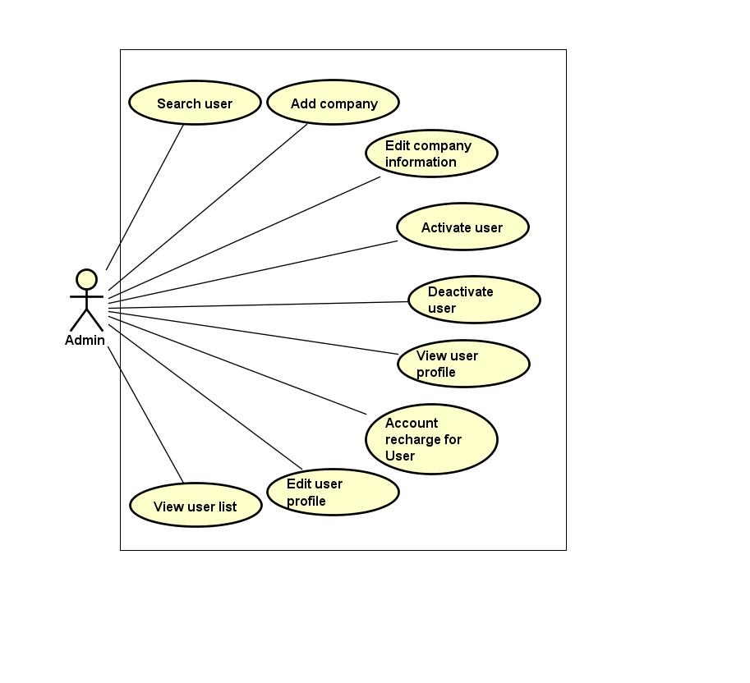

Figure ‑: Manage user group function

##### Search user

|  |  |  |  |  |
| --- | --- | --- | --- | --- |
| **Created by:** | | QuyetTD | **Date Created:** | 08/03/2017 |
| **Primary Actor** | | Administration | **Secondary Actor** |  |
| **Description:** | | Admin want to find a user in user list. Admin send request to system and then get result | | |
| **Preconditions:** | | 1. “QUẢN LÝ NGƯỜI DÙNG” navigator appear on header of website 2. Search box appear on list user page | | |
| **Trigger:** | | “QUẢN LÝ NGƯỜI DÙNG” navigator is clicked | | |
| **Post conditions:** | | Display user list by require of admin on list user page | | |
| **Normal Flow** | | | | |
| **Step** | **Actor** | **Action** | | |
| 1 | Admin | Click “Quản Lý User” navigator | | |
| 2 | CTC | Display search user page includes:   * “Tên người dùng” input text * “email” input text * “Tỉnh” input text * “Quyền truy cập”select box * “Tìm kiếm” button | | |
| 3 | Admin | Enter data in all or more than one fields | | |
| 4 | Admin | Click “Tìm Kiếm” button on manage user page | | |
| 5 | CTC | Display user list by require of admin on list user page | | |
| **Alternative Flows:** | | | | |
| **AT1** | At step 4 in the main flows, if user click other hyperlinks or buttons | | | |
| **Step** | **Actor** | **Action** | | |
| 5.1 | CTC | Redirects admin to chosen hyperlink or button | | |
| **Exceptions: N/A** | | | | |
| **Priority** | | Medium | | |
| **Frequency of Use:** | | Medium | | |
| **Business Rules:** | | N/A | | |
| **Other Information:** | | N/A | | |

Table ‑: Search user

##### View user profile

|  |  |  |  |  |
| --- | --- | --- | --- | --- |
| **Created by:** | | QuyetTD | **Date Created:** | 08/03/2017 |
| **Primary Actor** | | Administration | **Secondary Actor** |  |
| **Description:** | | Admin want to view user profile | | |
| **Preconditions:** | | 1. “QUẢN LÝ NGƯỜI DÙNG” navigator appear on header of website 2. Detail icon of bill of lading appear on list user page | | |
| **Trigger:** | | Detail icon of bill of lading is clicked | | |
| **Post conditions:** | | Display user detail on user detail page | | |
| **Normal Flow** | | | | |
| **Step** | **Actor** | **Action** | | |
| 1 | Admin | Click “Chi Tiết” on user detail page | | |
| 2 | CTC | Display user detail on user detail page | | |
| **Alternative Flows: N/A** | | | | |
| **Exceptions: N/A** | | | | |
| **Priority** | | Medium | | |
| **Frequency of Use:** | | Medium | | |
| **Business Rules:** | | B27 | | |
| **Other Information:** | | N/A | | |

Table ‑: View user profile

##### Edit company information

|  |  |  |  |  |  |
| --- | --- | --- | --- | --- | --- |
| **Created by:** | | | QuyetTD | **Date Created:** | 08/03/2017 |
| **Primary Actor** | | | Administration | **Secondary Actor** |  |
| **Description:** | | | Admin want to add company information to user. | | |
| **Preconditions:** | | | 1. “QUẢN LÝ NGƯỜI DÙNG” navigator appear on header of website 2. Detail icon of user detail appear on user detail page 3. “Thay Đổi” button appear on “Thông Tin Công Ty” box | | |
| **Trigger:** | | | “Thay Đổi” button is clicked | | |
| **Post conditions:** | | | Edit company information to user | | |
| **Normal Flow** | | | | | |
| **Step** | **Actor** | | **Action** | | |
| 1 | Admin | | Click “Thay đổi” button on view user company detail | | |
| 2 | CTC | | Display add company information for user pop-up includes:   * “Tên công ty” input text * “Email” input text * “Số điện thoại” input text * “Fax” input text * “Địa chỉ” input text * “Mã số thuế” input text * “Hủy bỏ” button | | |
| 3 | Admin | | * Enter data on fields * Click “Xác nhận” button | | |
| 4 | CTC | | * Edit company information for user | | |
| **Alternative Flows: N/A** | | | | | |
| **AT1** | At step 3 in the main flows, admin click “Hủy bỏ” button | | | | |
| **Step** | **Actor** | | **Action** | | |
| 4.1 | CTC | | Close “Chỉnh sửa thông tin công ty” pop-up | | |
| **Exceptions: N/A** | | | | | |
| **EC1** | | At step 3, required fields are not entered | | | |
| **Step** | | **Actor** | **Action** | | |
| 6.1 | | CTC | Display Register page with message error | | |
| 6.2 | | CTC | Mark error fields | | |
| **EC2** | | At step 3, fields are entered with wrong type of data | | | |
| **Step** | | **Actor** | **Action** | | |
| 6.1 | | CTC | Display Register page with message error | | |
| 6.2 | | CTC | Mark error fields | | |
| **Priority** | | | Medium | | |
| **Frequency of Use:** | | | Medium | | |
| **Business Rules:** | | | N/A | | |
| **Other Information:** | | | N/A | | |

Table ‑: Add company information

##### Edit user profile

|  |  |  |  |  |
| --- | --- | --- | --- | --- |
| **Created by:** | | QuyetTD | **Date Created:** | 08/03/2017 |
| **Primary Actor** | | Administration | **Secondary Actor** |  |
| **Description:** | | Admin want to change user profile | | |
| **Preconditions:** | | 1. “QUẢN LÝ NGƯỜI DÙNG” navigator appear on header of website 2. Detail icon of user detail appear on user detail page 3. “Thay Đổi” button appear on “Thông Tin Cá Nhân” box | | |
| **Trigger:** | | “Thay Đổi” button appear on “Thông Tin Cá Nhân” box is clicked | | |
| **Post conditions:** | | Save user profile in database and display user profile one detail user view page | | |
| **Normal Flow** | | | | |
| **Step** | **Actor** | **Action** | | |
| 1 | Admin | Admin click “Thay Đổi” button | | |
| 2 | CTC | Display pop-up includes:   * “Chọn ảnh” file chooser * “Họ tên” input text * “Bạn là” (phân quyền quản trị) check box * “Email” input text * “Địa chỉ” input text * “Chứng minh thư” input text * “Ngày cấp thẻ” date picker * “Ngày tham gia” date picker * “Thay Đổi” button | | |
| 3 | Admin | Change data in this fields | | |
| 4 | Admin | Click “Lưu Thay Đổi” button | | |
| 5 | CTC | Save changed in database | | |
| 6 | CTC | Display changed on detail user view page | | |
| **Alternative Flows:** | | | | |
| **AT1** | At step 4, admin click “x” in pop-up | | | |
| **Step** | **Actor** | **Action** | | |
| 6.1 | CTC | Display user detail page | | |
| **AT2** | At step 4 in the main flows, if user click other hyperlinks or buttons | | | |
| **Step** | **Actor** | **Action** | | |
| 6.1 | CTC | Redirects user to chosen hyperlink or button | | |
| **Exceptions: N/A** | | | | |
| **Priority** | | Medium | | |
| **Frequency of Use:** | | Medium | | |
| **Business Rules:** | | B27 | | |
| **Other Information:** | | N/A | | |

Table ‑: Edit user profile

##### Account recharge for user

|  |  |  |  |  |
| --- | --- | --- | --- | --- |
| **Created by:** | | QuyetTD | **Date Created:** | 08/03/2017 |
| **Primary Actor** | | Administration | **Secondary Actor** |  |
| **Description:** | | Admin want to recharge account for user | | |
| **Preconditions:** | | 1. “QUẢN LÝ NGƯỜI DÙNG” navigator appear on header of website 2. Detail icon of user detail appear on user detail page 3. “Nạp tiền” button appear on “Thông Tin Cá Nhân” box | | |
| **Trigger:** | | “Nạp Tiền” button on view user detail page is clicked | | |
| **Post conditions:** | | Recharge account for user | | |
| **Normal Flow** | | | | |
| **Step** | **Actor** | **Action** | | |
| 1 | Admin | Click “Nạp Tiền” button on view user detail page | | |
| 2 | CTC | Display Recharge account for user pop-up includes:   * “Số tiền” input text * “Xác nhận” button * “Hủy bỏ” button | | |
| 3 | Admin | * Enter data on “Số tiền” input text * Click “Xác nhận” button | | |
| 4 | Admin | * Recharge account for user * Updated view user detail page | | |
| **Alternative Flows: N/A** | | | | |
| **AT1** | At step 3 in the main flows, admin click “Hủy bỏ” button | | | |
| **Step** | **Actor** | **Action** | | |
| 4.1 | CTC | Close “Nạp Tiền” pop-up | | |
| **Exceptions: N/A** | | | | |
| **Priority** | | Medium | | |
| **Frequency of Use:** | | Medium | | |
| **Business Rules:** | | N/A | | |
| **Other Information:** | | N/A | | |

Table ‑: Account recharge for company

##### Activate user

|  |  |  |  |  |
| --- | --- | --- | --- | --- |
| **Created by:** | | QuyetTD | **Date Created:** | 08/03/2017 |
| **Primary Actor** | | Administration | **Secondary Actor** |  |
| **Description:** | | Admin want to active user account. This user can do something on website | | |
| **Preconditions:** | | 1. “QUẢN LÝ NGƯỜI DÙNG” navigator appear on header of website 2. Activate icon of user appear on user detail page 3. User is deactivated | | |
| **Trigger:** | | Activate icon of user appear on user detail page is clicked | | |
| **Post conditions:** | | User become active status | | |
| **Normal Flow** | | | | |
| **Step** | **Actor** | **Action** | | |
| 1 | Admin | Click “Active” button one user list page | | |
| 2 | CTC | Active account to active status | | |
| **Alternative Flows: N/A** | | | | |
| **Exceptions: N/A** | | | | |
| **Priority** | | High | | |
| **Frequency of Use:** | | Medium | | |
| **Business Rules:** | | B27 | | |
| **Other Information:** | | N/A | | |

Table ‑: Activate user

##### Deactivate user

|  |  |  |  |  |
| --- | --- | --- | --- | --- |
| **Created by:** | | QuyetTD | **Date Created:** | 08/03/2017 |
| **Primary Actor** | | Administration | **Secondary Actor** |  |
| **Description:** | | Admin want to make an account to deactivate. This account can’t work on website | | |
| **Preconditions:** | | 1. “QUẢN LÝ NGƯỜI DÙNG” navigator appear on header of website 2. Activate icon of user appear on user detail page 3. User is active | | |
| **Trigger:** | | Deactivate icon on user list page is clicked | | |
| **Post conditions:** | | Admin is deactivation status and this user can’t work on website | | |
| **Normal Flow** | | | | |
| **Step** | **Actor** | **Action** | | |
| 1 | Admin | Click “Deactivate” button on user list page | | |
| 2 | CTC | Set user to deactivation status | | |
| **Alternative Flows: N/A** | | | | |
| **Exceptions: N/A** | | | | |
| **Priority** | | High | | |
| **Frequency of Use:** | | Medium | | |
| **Business Rules:** | | B27 | | |
| **Other Information:** | | N/A | | |

Table ‑: Deactivate user

##### Add company

|  |  |  |  |  |  |
| --- | --- | --- | --- | --- | --- |
| **Created by:** | | | QuyetTD | **Date Created:** | 08/03/2017 |
| **Primary Actor** | | | Administration | **Secondary Actor** |  |
| **Description:** | | | Admin want to add company information to user. | | |
| **Preconditions:** | | | 1. “QUẢN LÝ NGƯỜI DÙNG” navigator appear on header of website 2. Detail icon of user appear on user detail page 3. “Thêm mới” button appear on “Thông tin công ty” box | | |
| **Trigger:** | | | “Thêm mới” button on view user detail page is clicked | | |
| **Post conditions:** | | | Add company information to user | | |
| **Normal Flow** | | | | | |
| **Step** | **Actor** | | **Action** | | |
| 1 | Admin | | Click “Thêm mới” button on view user detail page | | |
| 2 | CTC | | Display add company information for user pop-up includes:   * “Tên công ty” input text * “Email” input text * “Số điện thoại” input text * “Fax” input text * “Địa chỉ” input text * “Mã số thuế” input text * “Hủy bỏ” button | | |
| 3 | Admin | | * Enter data on fields * Click “Xác nhận” button | | |
| 4 | CTC | | * Add company information for user | | |
| **Alternative Flows: N/A** | | | | | |
| **AT1** | At step 3 in the main flows, admin click “Hủy bỏ” button | | | | |
| **Step** | **Actor** | | **Action** | | |
| 4.1 | CTC | | Close “Thêm thông tin công ty” pop-up | | |
| **Exceptions: N/A** | | | | | |
| **EC1** | | At step 3, required fields are not entered | | | |
| **Step** | | **Actor** | **Action** | | |
| 6.1 | | CTC | Display Register page with message error | | |
| 6.2 | | CTC | Mark error fields | | |
| **EC2** | | At step 3, fields are entered with wrong type of data | | | |
| **Step** | | **Actor** | **Action** | | |
| 6.1 | | CTC | Display Register page with message error | | |
| 6.2 | | CTC | Mark error fields | | |
| **Priority** | | | Medium | | |
| **Frequency of Use:** | | | Medium | | |
| **Business Rules:** | | | N/A | | |
| **Other Information:** | | | N/A | | |

Table ‑: Add company

##### View user list

|  |  |  |  |  |
| --- | --- | --- | --- | --- |
| **Created by:** | | QuyetTD | **Date Created:** | 08/03/2017 |
| **Primary Actor** | | Administration | **Secondary Actor** |  |
| **Description:** | | Admin want to view user list of CTC | | |
| **Preconditions:** | | “QUẢN LÝ NGƯỜI DÙNG” navigator appear on header of website | | |
| **Trigger:** | | “QUẢN LÝ NGƯỜI DÙNG” navigator is clicked | | |
| **Post conditions:** | | Display user list on list user page | | |
| **Normal Flow** | | | | |
| **Step** | **Actor** | **Action** | | |
| 1 | Admin | Click “Quản lý người dùng” navigator | | |
| 2 | CTC | Display user list on list user page | | |
| **Alternative Flows: N/A** | | | | |
| **Exceptions: N/A** | | | | |
| **Priority** | | Medium | | |
| **Frequency of Use:** | | Medium | | |
| **Business Rules:** | | N/A | | |
| **Other Information:** | | N/A | | |

Table ‑: View user list

#### Price list group function

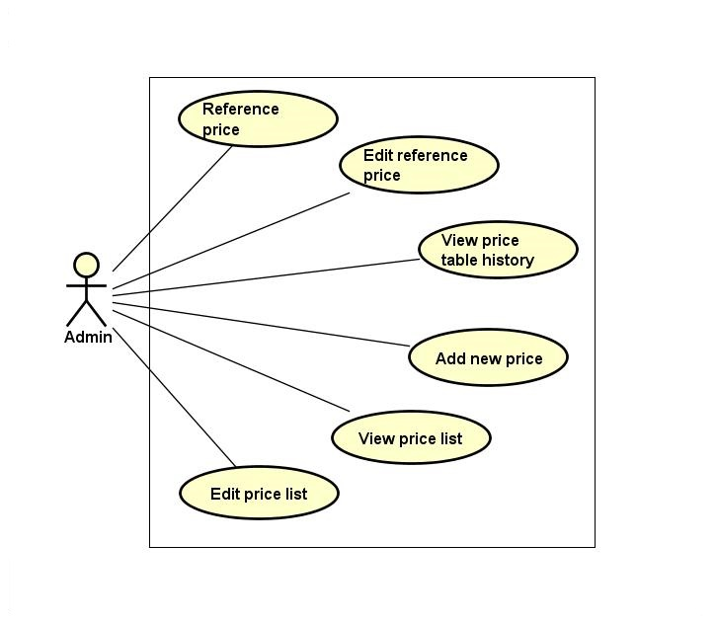

Figure ‑: Price list group function

##### View price list

|  |  |  |  |  |
| --- | --- | --- | --- | --- |
| **Created by:** | | QuyetTD | **Date Created:** | 08/03/2017 |
| **Primary Actor** | | Administration | **Secondary Actor** |  |
| **Description:** | | Admin want to view list of price | | |
| **Preconditions:** | | 1. “Hệ Thống” item appear on header of website 2. “BÁO GIÁ” navigator appear on header of website | | |
| **Trigger:** | | “Hệ Thống” item is clicked | | |
| **Post conditions:** | | Display price list on price list page | | |
| **Normal Flow** | | | | |
| **Step** | **Actor** | **Action** | | |
| 1 | Admin | Hover mouse to “Báo Giá” navigator and then click “Hệ Thống” item | | |
| 2 | CTC | Display price list on price list page | | |
| **Alternative Flows: N/A** | | | | |
| **Exceptions: N/A** | | | | |
| **Priority** | | High | | |
| **Frequency of Use:** | | High | | |
| **Business Rules:** | | N/A | | |
| **Other Information:** | | N/A | | |

Table ‑: View price list

##### Edit price list

|  |  |  |  |  |
| --- | --- | --- | --- | --- |
| **Created by:** | | QuyetTD | **Date Created:** | 08/03/2017 |
| **Primary Actor** | | Administration | **Secondary Actor** |  |
| **Description:** | | Admin want to edit price for match with real price | | |
| **Preconditions:** | | 1. “Hệ Thống” item appear on header of website 2. “BÁO GIÁ” navigator appear on header of website 3. Detail icon of price appear on list operation free page | | |
| **Trigger:** | | Detail icon of price is clicked | | |
| **Post conditions:** | | Save changed in database and display “chỉnh sửa thành công” message on pop-up. | | |
| **Normal Flow** | | | | |
| **Step** | **Actor** | **Action** | | |
| 1 | Admin | Enter some fields on edit price page | | |
| 2 | Admin | Click “Xác Nhận” on edit price page | | |
| 3 | CTC | Save changed in database and display “chỉnh sửa thành công” message on pop-up | | |
| **Alternative Flows:** | | | | |
| **AT1** | At step 2, admin click “Hủy Bỏ” button on edit page | | | |
| **Step** | **Actor** | **Action** | | |
| 3.1 | CTC | System return to price list page | | |
| **AT2** | At step 4 in the main flows, if admin click other hyperlinks or buttons | | | |
| **Step** | **Actor** | **Action** | | |
| 3.1 | CTC | Redirects user to chosen hyperlink or button | | |
| **Exceptions: N/A** | | | | |
| **Priority** | | High | | |
| **Frequency of Use:** | | Medium | | |
| **Business Rules:** | | N/A | | |
| **Other Information:** | | N/A | | |

Table ‑: Edit price list

##### View price table history

|  |  |  |  |  |
| --- | --- | --- | --- | --- |
| **Created by:** | | QuyetTD | **Date Created:** | 08/03/2017 |
| **Primary Actor** | | Administration | **Secondary Actor** |  |
| **Description:** | | Admin want to view history of price table | | |
| **Preconditions:** | | 1. “Hệ Thống” item appear on header of website 2. “BÁO GIÁ” navigator appear on header of website 3. Search box appear on list operation free page | | |
| **Trigger:** | | “Hệ Thống” item is clicked | | |
| **Post conditions:** | | Display price history list | | |
| **Normal Flow** | | | | |
| **Step** | **Actor** | **Action** | | |
| 1 | Admin | Hover mouse to “Báo Giá” navigator and click “Tham chiếu” item | | |
| 2 | CTC | Display price list from other website includes:   * Cost types status Select box * “Tìm kiếm” button | | |
| 3 | Admin | * Select “Lịch sử” item or “đang áp dụng” item * Click “Tìm kiếm” button | | |
| 4 | Admin | * Display price table history | | |
| **Alternative Flows: N/A** | | | | |
| **Exceptions: N/A** | | | | |
| **Priority** | | Medium | | |
| **Frequency of Use:** | | Medium | | |
| **Business Rules:** | | N/A | | |
| **Other Information:** | | N/A | | |

Table ‑: View price table history

##### Add a new price

|  |  |  |  |  |
| --- | --- | --- | --- | --- |
| **Created by:** | | QuyetTD | **Date Created:** | 08/03/2017 |
| **Primary Actor** | | Administration | **Secondary Actor** |  |
| **Description:** | | Admin want to add a new price to system | | |
| **Preconditions:** | | 1. “HỆ THỐNG” item appear on header of website 2. “THÊM MỚI” item appear on header of website | | |
| **Trigger:** | | “THÊM MỚI” item appear on header of website is clicked | | |
| **Post conditions:** | | Add new price to database and display “thêm mới thành công” message on pop-up | | |
| **Normal Flow** | | | | |
| **Step** | **Actor** | **Action** | | |
| 1 | Admin | Hover mouse to “Báo Giá” navigator and click “Thêm Mới” item | | |
| 2 | CTC | Display add new price includes:   * “Tên chi phí” input text * “Mã chi phí” input text * “Loại” check box * “Chi phí” input text * “Tỷ lệ chi phí” input text * “Mô tả” input text * “Thêm mới” button * “Hủy bỏ” button | | |
| 3 | Admin | Enter some fields on add new price page | | |
| 4 | Admin | Click “Thêm Mới” on add new price page | | |
| 5 | CTC | Add a new price to database | | |
| 6 | CTC | Add new price to database and display “thêm mới thành công” message on pop-up | | |
| **Alternative Flows:** | | | | |
| **AT1** | At step 4, admin click “Hủy Bỏ” button | | | |
| **Step** | **Actor** | **Action** | | |
| 6 | CTC | System return to price list page | | |
| **AT2** | At step 4 in the main flows, if user click other hyperlinks or buttons | | | |
| **Step** | **Actor** | **Action** | | |
| 5.1 | CTC | Redirects user to chosen hyperlink or button | | |
| **Exceptions:** | | | | |
| **EC1** | At step 2, required fields are not entered | | | |
| **Step** | **Actor** | **Action** | | |
| 2.1 | CTC | Display Register page with message error | | |
| 2.2 | CTC | Mark error fields | | |
| **EC2** | At step 4, fields are entered with wrong type of data | | | |
| **Step** | **Actor** | **Action** | | |
| 2.1 | CTC | Display Register page with message error | | |
| 2.1 | CTC | Mark error fields | | |
| **Priority** | | High | | |
| **Frequency of Use:** | | High | | |
| **Business Rules:** | | B28, B29, B30, B31, B32 | | |
| **Other Information:** | | N/A | | |

Table ‑: Add new price

##### Reference price

|  |  |  |  |  |
| --- | --- | --- | --- | --- |
| **Created by:** | | QuyetTD | **Date Created:** | 08/03/2017 |
| **Primary Actor** | | Administration | **Secondary Actor** |  |
| **Description:** | | Admin want to reference real price | | |
| **Preconditions:** | | 1. “Tham Chiếu” item appear on header of website 2. “BÁO GIÁ” navigator appear on header of website | | |
| **Trigger:** | | “Tham chiếu” item is clicked | | |
| **Post conditions:** | | Display price list | | |
| **Normal Flow** | | | | |
| **Step** | **Actor** | **Action** | | |
| 1 | Admin | Hover mouse to “BÁO GIÁ” navigator and Click “Tham chiếu” item | | |
| 2 | CTC | Display price list from other website | | |
| **Alternative Flows: N/A** | | | | |
| **Exceptions: N/A** | | | | |
| **Priority** | | Medium | | |
| **Frequency of Use:** | | Medium | | |
| **Business Rules:** | | N/A | | |
| **Other Information:** | | N/A | | |

Table ‑: Reference price

##### Edit reference price

|  |  |  |  |  |  |
| --- | --- | --- | --- | --- | --- |
| **Created by:** | | QuyetTD | | **Date Created:** | 08/03/2017 |
| **Primary Actor** | | Administration | | **Secondary Actor** |  |
| **Description:** | | Admin want to edit reference price list | | | |
| **Preconditions:** | | 1. “THAM CHIẾU” item appear on header of website 2. “BÁO GIÁ” navigator appear on header of website 3. Detail icon of price appear on list operation free | | | |
| **Trigger:** | | Detail icon of price appear on list operation free is clicked | | | |
| **Post conditions:** | | Update new reference price | | | |
| **Normal Flow** | | | | | |
| **Step** | **Actor** | **Action** | | | |
| 1 | Admin | Hover mouse to “Báo Giá” navigator and click “Tham chiếu” item and click detail icon of price | | | |
| 2 | CTC | Display reference price list | | | |
| 3 | Admin | Click detail icon | | | |
| 4 | CTC | Display “Nhập giá tham chiếu” popup includes:  “Giá tham chiếu” input text  “Xác nhận” button  “Hủy bỏ” button | | | |
| 5 | Admin | Enter data in field | | | |
| 6 | Admin | Click “Xác Nhận” button | | | |
| 7 | CTC | Display “Chỉnh sửa thành công” message in popup | | | |
| **Alternative Flows: N/A** | | | | | |
| **AT1** | At step 6, admin click “Hủy Bỏ” button | | | | |
| **Step** | **Actor** | | **Action** | | |
| 6.1 | CTC | | System return to price list page | | |
| **AT2** | At step 6 in the main flows, if user click other hyperlinks or buttons | | | | |
| **Step** | **Actor** | | **Action** | | |
| 6.1 | CTC | | Redirects user to chosen hyperlink or button | | |
| **Exceptions: N/A** | | | | | |
| **Priority** | | Medium | | | |
| **Frequency of Use:** | | Medium | | | |
| **Business Rules:** | | N/A | | | |
| **Other Information:** | | N/A | | | |

Table ‑: Edit reference price

#### Manage report group list

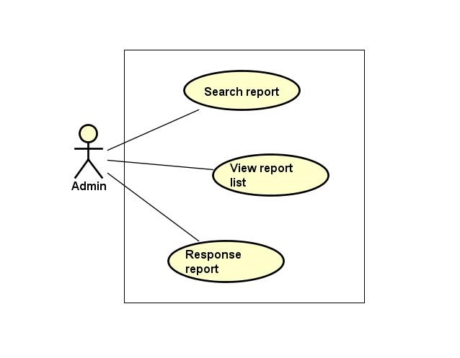

Figure ‑: Manage report group list

##### Search report

|  |  |  |  |  |  |  |
| --- | --- | --- | --- | --- | --- | --- |
| **Created by:** | | | QuyetTD | | **Date Created:** | 08/03/2017 |
| **Primary Actor** | | | Administration | | **Secondary Actor** |  |
| **Description:** | | | Admin want to find a report in report list | | | |
| **Preconditions:** | | | 1. “BÁO CÁO TỪ NGƯỜI DÙNG” navigator appear header of website 2. Search box appear on list report user page | | | |
| **Trigger:** | | | “BÁO CÁO CỦA TÔI” navigator appear header of website | | | |
| **Post conditions:** | | | Display report on report list page | | | |
| **Normal Flow** | | | | | | |
| **Step** | **Actor** | | **Action** | | | |
| 1 | Admin | | Admin click “Quản Lý Report” navigator | | | |
| 2 | CTC | | Display search page includes:   * “Tên tài khoản” input text * “Tên người dung” input text * “Tiêu đề báo cáo” input text * “ngày bắt đầu” input text * “ngày kết thúc” input text * “Tìm kiếm” button | | | |
| 3 | Admin | | Enter data in fields | | | |
| 4 | Admin | | Click “Tìm kiếm” button | | | |
| 5 | CTC | | Display result on report list page | | | |
| **Alternative Flows:** | | | | | | |
| **AT1** | | At step 4 in the main flows, if admin click other hyperlinks or buttons | | | | |
| **Step** | | **Actor** | | **Action** | | |
| 5.1 | | CTC | | Redirects user to chosen hyperlink or button | | |
| **Exceptions: N/A** | | | | | | |
| **Priority** | | | Medium | | | |
| **Frequency of Use:** | | | Medium | | | |
| **Business Rules:** | | | N/A | | | |
| **Other Information:** | | | N/A | | | |

Table ‑: Search report

##### View report list

|  |  |  |  |  |
| --- | --- | --- | --- | --- |
| **Created by:** | | QuyetTD | **Date Created:** | 08/03/2017 |
| **Primary Actor** | | Administration | **Secondary Actor** |  |
| **Description:** | | Admin want to view report list | | |
| **Preconditions:** | | “BÁO CÁO TỪ NGƯỜI DÙNG” navigator appear header of website | | |
| **Trigger:** | | “BÁO CÁO CỦA TÔI” navigator appear header of website | | |
| **Post conditions:** | | Display report list on report list page | | |
| **Normal Flow** | | | | |
| **Step** | **Actor** | **Action** | | |
| 1 | Admin | Click “Báo Cáo Của Tôi” navigator | | |
| 2 | CTC | Display report list on report list page | | |
| **Alternative Flows: N/A** | | | | |
| **Exceptions: N/A** | | | | |
| **Priority** | | Medium | | |
| **Frequency of Use:** | | High | | |
| **Business Rules:** | | N/A | | |
| **Other Information:** | | N/A | | |

Table ‑: View report list

##### Response report

|  |  |  |  |  |
| --- | --- | --- | --- | --- |
| **Created by:** | | QuyetTD | **Date Created:** | 08/03/2017 |
| **Primary Actor** | | Administration | **Secondary Actor** |  |
| **Description:** | | Admin want to response report to goods owner or carrier | | |
| **Preconditions:** | | 1. “BÁO CÁO TỪ NGƯỜI DÙNG” navigator appear header of website | | |
| **Trigger:** | | “Tiêu Đề Báo Cáo” is clicked | | |
| **Post conditions:** | | Response report to goods owner or carrier | | |
| **Normal Flow** | | | | |
| **Step** | **Actor** | **Action** | | |
| 1 | Admin | Click “Tiêu Đề Báo Cáo” link | | |
| 2 | CTC | Display response report page includes:   * Report of user detail (sender, receiver, account of sender, send date, question from sender, hoping) * “Nội dung” input text * “Phản hồi” button * “Quay lại” button | | |
| 3 | Admin | Enter data in fields | | |
| 4 | Admin | Click “Xác nhận” button | | |
| 5 | CTC | Response report to sender | | |
| **Alternative Flows:** | | | | |
| **AT1** | At step 4, admin click “Quay lại” button | | | |
| **Step** | **Actor** | **Action** | | |
| 5.1 | CTC | Display report list page | | |
| **AT2** | At step 4 in the main flows, if admin click other hyperlinks or buttons | | | |
| **Step** | **Actor** | **Action** | | |
| 5.1 | CTC | Redirects user to chosen hyperlink or button | | |
| **Exceptions: N/A** | | | | |
| **Priority** | | Medium | | |
| **Frequency of Use:** | | Medium | | |
| **Business Rules:** | | N/A | | |
| **Other Information:** | | N/A | | |

Table ‑: Response report

#### Manage profile group function

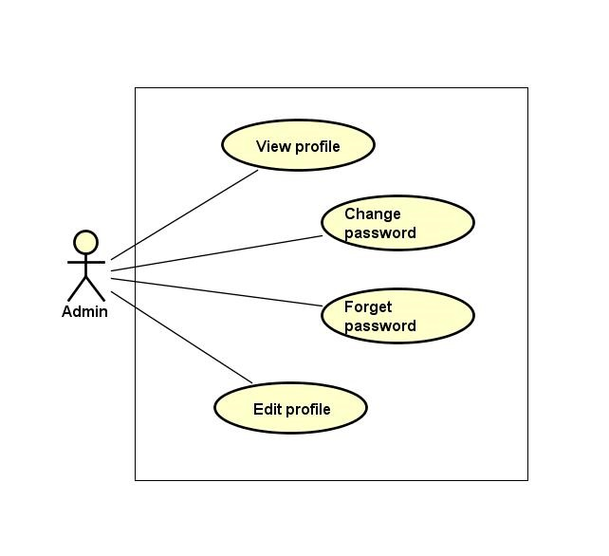

Figure ‑: Manage profile group function

##### View profile

|  |  |  |  |  |
| --- | --- | --- | --- | --- |
| **Created by:** | | QuyetTD | **Date Created:** | 08/03/2017 |
| **Primary Actor** | | Administration | **Secondary Actor** |  |
| **Description:** | | Admin want to view admin’s profile | | |
| **Preconditions:** | | “Thông Tin Cá Nhân” item appear on top navigator | | |
| **Trigger:** | | “Thông Tin Cá Nhân” item is clicked | | |
| **Post conditions:** | | Display admin profile on detail user view page | | |
| **Normal Flow** | | | | |
| **Step** | **Actor** | **Action** | | |
| 1 | Admin | Hover mouse to user name label and click “Thông Tin Cá Nhân” item | | |
| 2 | CTC | Display admin profile on detail user view page | | |
| **Alternative Flows: N/A** | | | | |
| **Exceptions: N/A** | | | | |
| **Priority** | | Medium | | |
| **Frequency of Use:** | | High | | |
| **Business Rules:** | | N/A | | |
| **Other Information:** | | N/A | | |

Table ‑: View profile

##### Edit profile

|  |  |  |  |  |
| --- | --- | --- | --- | --- |
| **Created by:** | | QuyetTD | **Date Created:** | 08/03/2017 |
| **Primary Actor** | | Administration | **Secondary Actor** |  |
| **Description:** | | Admin want to edit admin profile | | |
| **Preconditions:** | | “Thay Đổi” button appear on detail user view page | | |
| **Trigger:** | | “Thay Đổi” button on detail user view page is clicked | | |
| **Post conditions:** | | Save admin profile in database and display successful message | | |
| **Normal Flow** | | | | |
| **Step** | **Actor** | **Action** | | |
| 1 | Admin | Hover mouser to user name label and clicj “Chỉnh Sửa Thông Tin” item | | |
| 2 | CTC | Display pop-up includes:   * “Chọn ảnh” file chooser * “Họ tên” input text * “Bạn là” (phân quyền quản trị) check box * “Email” input text * “Địa chỉ” input text * “Chứng minh thư” input text * “Ngày cấp thẻ” date picker * “Ngày tham gia” date picker * “Thay Đổi” button | | |
| 3 | Admin | Change data in this fields | | |
| 4 | Admin | Click “Lưu Thay Đổi” button | | |
| 5 | CTC | Save changed in database | | |
| 6 | CTC | Display successful message | | |
| **Alternative Flows:** | | | | |
| **AT1** | At step 4, admin click “x” in pop-up | | | |
| **Step** | **Actor** | **Action** | | |
| 6.1 | CTC | Display user detail page | | |
| **AT2** | At step 4 in the main flows, if admin click other hyperlinks or buttons | | | |
| **Step** | **Actor** | **Action** | | |
| 6.1 | CTC | Redirects admin to chosen hyperlink or button | | |
| **Exceptions: N/A** | | | | |
| **Priority** | | Medium | | |
| **Frequency of Use:** | | Medium | | |
| **Business Rules:** | | N/A | | |
| **Other Information:** | | N/A | | |

Table ‑: Edit profile

##### Change password

|  |  |  |  |  |  |
| --- | --- | --- | --- | --- | --- |
| **Created by:** | | | QuyetTD | **Date Created:** | 08/03/2017 |
| **Primary Actor** | | | Administration | **Secondary Actor** |  |
| **Description:** | | | Admin want to change password for security | | |
| **Preconditions:** | | | “Thay đổi mật khẩu” item appear on top navigator | | |
| **Trigger:** | | | “Thay đổi mật khẩu” item is clicked | | |
| **Post conditions:** | | | Change admin’s password | | |
| **Normal Flow** | | | | | |
| **Step** | **Actor** | | **Action** | | |
| 1 | Admin | | Hover mouse to user name label and click “Đổi mật khẩu” item | | |
| 2 | CTC | | Display change password page includes:   * “Mật khẩu cũ” input text * “Mật khẩu mới” input text * “Xác nhận mật khẩu” input text * “Đổi mật khẩu” button input text | | |
| 3 | Admin | | Enter data in this fields | | |
| 4 | Admin | | Click “Đổi mật khẩu” button | | |
| 5 | CTC | | Save new password in database | | |
| 6 | CTC | | Return to homepage | | |
| **Alternative Flows:** | | | | | |
| **AT1** | At step 4 in the main flows, if admin click other hyperlinks or buttons | | | | |
| **Step** | **Actor** | | **Action** | | |
| 6.1 | CTC | | Redirects admin to chosen hyperlink or button | | |
| **Exceptions:** | | | | | |
| **EC1** | | At step 3, required fields are not entered | | | |
| **Step** | | **Actor** | **Action** | | |
| 6.1 | | CTC | Display Register page with message error | | |
| 6.2 | | CTC | Mark error fields | | |
| **EC2** | | At step 3, fields are entered with wrong type of data | | | |
| **Step** | | **Actor** | **Action** | | |
| 6.1 | | CTC | Display Register page with message error | | |
| 6.2 | | CTC | Mark error fields | | |
| **EC3** | | At step 3, password is wrong | | | |
| **Step** | | **Actor** | **Action** | | |
| 6.1 | | CTC | Display Register page with message error | | |
| 6.2 | | CTC | Mark error fields | | |
| **EC4** | | At step 3, new password and confirm password are not match | | | |
| **Step** | | **Actor** | **Action** | | |
| 6.1 | | CTC | Display Register page with message error | | |
| 6.2 | | CTC | Mark error fields | | |
| **Priority** | | | Medium | | |
| **Frequency of Use:** | | | Medium | | |
| **Business Rules:** | | | B12, B15 | | |
| **Other Information:** | | | N/A | | |

Table ‑: Change password

##### Forget password

|  |  |  |  |  |
| --- | --- | --- | --- | --- |
| **Created by:** | | QuyetTD | **Date Created:** | 08/03/2017 |
| **Primary Actor** | | Administration | **Secondary Actor** |  |
| **Description:** | | Admin forget password. They want to reset password | | |
| **Preconditions:** | | “Quên mật khẩu” label appear on login page | | |
| **Trigger:** | | “Quên mật khẩu” label on login page is clicked | | |
| **Post conditions:** | | System send new password to admin’s email | | |
| **Normal Flow** | | | | |
| **Step** | **Actor** | **Action** | | |
| 1 | Admin | Admin click “Quên mật khẩu” label on login page | | |
| 2 | CTC | Display forget password page includes:   * “Email đăng ký” input text * “Gửi” button | | |
| 3 | Admin | Enter email address they use for register admin account | | |
| 4 | CTC | Send new password to admin’s email address | | |
| **Alternative Flows:** | | | | |
| **AT1** | At step 4 in the main flows, if admin click other hyperlinks or buttons | | | |
| **Step** | **Actor** | **Action** | | |
| 6.1 | CTC | Redirects admin to chosen hyperlink or button | | |
| **Exceptions: N/A** | | | | |
| **Priority** | | Medium | | |
| **Frequency of Use:** | | High | | |
| **Business Rules:** | | B22 | | |
| **Other Information:** | | N/A | | |

Table ‑: Forget password

#### Transaction history group function

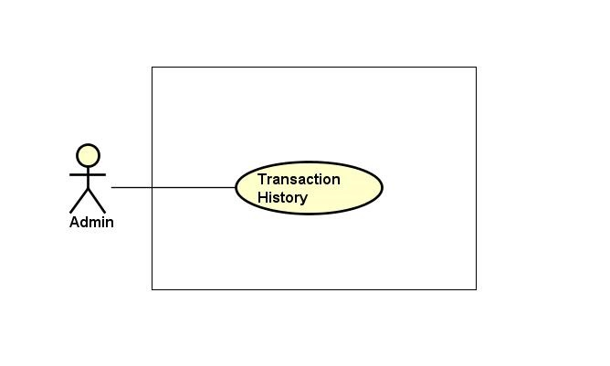

Figure ‑: Transaction history group function

##### Transaction history

|  |  |  |  |  |
| --- | --- | --- | --- | --- |
| **Created by:** | | QuyetTD | **Date Created:** | 08/03/2017 |
| **Primary Actor** | | Administration | **Secondary Actor** |  |
| **Description:** | | Admin want to check money in account and what did they do with money | | |
| **Preconditions:** | | “Thông tin giao dịch” item appear on top navigator | | |
| **Trigger:** | | “Thông tin giao dịch” item is clicked | | |
| **Post conditions:** | | Display money in account and transaction history | | |
| **Normal Flow** | | | | |
| **Step** | **Actor** | **Action** | | |
| 1 | Admin | Hover mouse to user name and Click “Thông tin giao dịch” item | | |
| 2 | CTC | Display money in account and transaction history | | |
| **Alternative Flows: N/A** | | | | |
| **Exceptions: N/A** | | | | |
| **Priority** | | Medium | | |
| **Frequency of Use:** | | Medium | | |
| **Business Rules:** | | N/A | | |
| **Other Information:** | | N/A | | |

Table ‑: Transaction history

#### Login group function

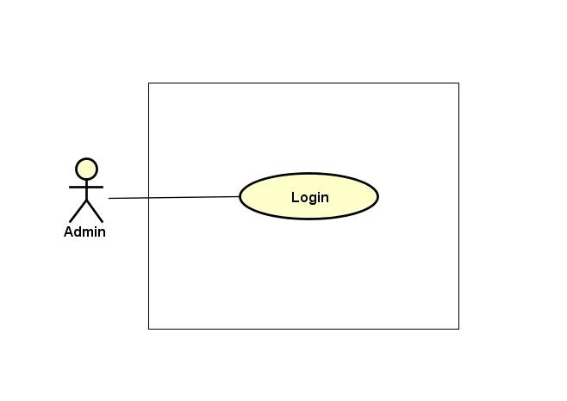

Figure ‑: Login group function

##### Login

|  |  |  |  |  |  |  |
| --- | --- | --- | --- | --- | --- | --- |
| **Created by:** | | | QuyetTD | | **Date Created:** | 08/03/2017 |
| **Primary Actor** | | | Administration | | **Secondary Actor** |  |
| **Description:** | | | Admin want to login to CTC system for work | | | |
| **Preconditions:** | | | “Đăng nhập” button appear on login page | | | |
| **Trigger:** | | | “Đăng nhập” button on login page is clicked | | | |
| **Post conditions:** | | | Admin login to CTC system | | | |
| **Normal Flow** | | | | | | |
| **Step** | **Actor** | | **Action** | | | |
| 1 | Admin | | Click “Đăng nhập” label on homepage | | | |
| 2 | CTC | | Display login page includes:   * “Email” input text * “Mật khẩu” input text * “Đăng nhập” button | | | |
| 3 | Admin | | Enter data in fields | | | |
| 4 | Admin | | Click “Đăng nhập” button | | | |
| 5 | CTC | | Login account to CTC | | | |
| **Alternative Flows:** | | | | | | |
| **AT1** | At step 4 in the main flows, if admin click other hyperlinks or buttons | | | | | |
| **Step** | **Actor** | | **Action** | | | |
| 5.1 | CTC | | Redirects admin to chosen hyperlink or button | | | |
| **Exceptions: N/A** | | | | | | |
| **EC1** | | At step 3, required fields are not entered | | | | |
| **Step** | | **Actor** | | **Action** | | |
| 4.1 | | CTC | | Display Register page with message error | | |
| 4.2 | | CTC | | Mark error fields | | |
| **EC2** | | At step 3, fields are entered with wrong type of data | | | | |
| **Step** | | **Actor** | | **Action** | | |
| 4.1 | | CTC | | Display Register page with message error | | |
| 4.2 | | CTC | | Mark error fields | | |
| **Priority** | | | High | | | |
| **Frequency of Use:** | | | High | | | |
| **Business Rules:** | | | B2, B11 | | | |
| **Other Information:** | | | N/A | | | |

Table ‑: Login

#### Logout group function

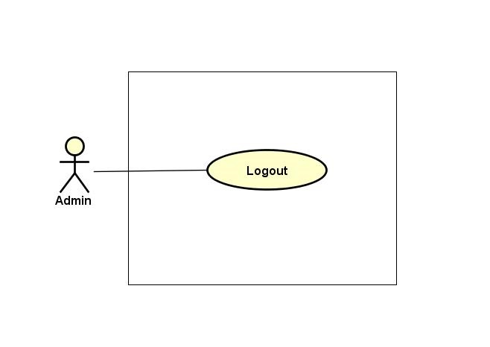

Figure ‑: Logout group function

##### Logout

|  |  |  |  |  |
| --- | --- | --- | --- | --- |
| **Created by:** | | QuyetTD | **Date Created:** | 08/03/2017 |
| **Primary Actor** | | Administration | **Secondary Actor** |  |
| **Description:** | | Admin want to logout CTC system | | |
| **Preconditions:** | | “Đăng xuất” button appear on top navigator | | |
| **Trigger:** | | “Đăng xuất” button is clicked | | |
| **Post conditions:** | | Logout admin account | | |
| **Normal Flow** | | | | |
| **Step** | **Actor** | **Action** | | |
| 1 | Admin | Click “Đăng xuất” label in website | | |
| 2 | CTC | Logout admin account | | |
| 3 | CTC | Return homepage | | |
| **Alternative Flows: N/A** | | | | |
| **Exceptions: N/A** | | | | |
| **Priority** | | High | | |
| **Frequency of Use:** | | High | | |
| **Business Rules:** | | N/A | | |
| **Other Information:** | | N/A | | |

Table ‑: Logout

# **NON-FUNCTIONAL SPECIFICATION**

## **Reliability**

* Mean time between failures: The mean time between each failure is expected to be about 500 hours of using.
* Database data is not deleted, for data restoration or recall history when we needed
* The maximum bugs per function are 1 bugs/a function when user uses software within 2 months.
* System errors must be repaired no more than 3 days after detected.

## **Performance Requirements**

### **Availability**

The application must be available 99% of time. Users can access to it everywhere from their

Web browser with internet connection.

### **Response time**

In term of response time, waiting time of processing will be 2 to 5 seconds; time to process any functions no more than 3 seconds

### **Maintainability**

* Strictly follow the coding convention to help improve readability of source code and make the website more maintainable.
* Develop website based on Object Oriented Programming paradigm in order to increase maintainability and extendibility.

### **Usability**

Usability Requirements support the following from the perspective of its primary users:

* Efficiency of use: user can complete each function in less than 40 actions
* Intuitiveness: User can understand approximately 95% help/ error messages
* All of screen should be elegant and simple.
* All attributes are provided for non-text elements, such as images and maps.
* Search box is wide enough, so that users can see what they have typed.
* Links are easily recognizable. They look clickable. Items that are not links do not look clickable, for example underlining text is avoided.
* Colors must be uniform
* The buttons must be large enough and not too large

### **Security Requirements**

* When registering, user must use the correct email address. So they can access to confirm link in email.
* Sensitive information is stored in md5 format in database.
* Using access control.
* Sensitive information is encrypted before transmission.
* Use SSL certificate number.

### **Hardware/Software Requirements**

* **Hardware requirement:**

**- Server:** Web service 2013, IIS8

**-** **Client:** PC/Laptop (window 7, window 8, window 10)

* **Software requirements:** Web browser (Chrome 40.0, Firefox 30.0) with internet connection